Appendix A: Third microsatellite (< 60 kg) through international collaboration

The baseline FACTORS mission is composed of two spacecraft, instead of three. This is mainly due to the budget constraint (cf. Section 16). Scientifically it is highly desirable if a third spacecraft can be added through external international collaboration (cf. Section 11). A third-point observation enables to resolve the 2D structure and dynamics of auroral physical processes perpendicular to the background magnetic field on a scale larger than ion/electron characteristic lengths (cf. Section 6). The third spacecraft can be a microsatellite with smaller payload than the baseline spacecraft of FACTORS. The provision of a microsatellite would be also very attractive for the external partner because it would allow maximizing the scientific output by combining the data with the two baseline spacecraft.

Swedish microsatellite (Innosat) as the possible third satellite
One such candidate for the additional third spacecraft could be a microsatellite provided by Sweden under their own program (Sections 9, 11). Sweden has a strong tradition of experimental space physics, and is the second country (after Canada) that made science satellites without having own orbiter-launch system. Most of these Swedish science missions are plasma missions related to aurora-related science (Viking 1986, Freja 1992, Astrid-1 1995, Astrid-2 1998, Munin 2000). All except Munin were manufactured by OHB-Sweden.

With such background, Swedish National Space Agency (SNSA) initiated a microsatellite program (original name was Innosat program) where the first two selected missions are based on a platform that is a near cubic form microsatellite of 60 cm, in 50-60 kg class with about 15-20 kg payload (the name Innosat now means this platform rather than the program). The first microsatellites MATS (original name is Innosat-1) is planned to launch autumn 2022, and the second microsatellite is under manufacturing.

As is 2021, SNSA plans to continue microsatellite program of this size with a planned cycle of about one microsatellite each 3-5 years and the project time maximum of about 4 years after the proposal submission (cf. Section 5). This means that we expect AO for the third microsatellite mission around 2023-2024, and the fourth microsatellite some time after 2026. These opportunities can be good candidates to propose a microsatellite for the possible third spacecraft of FACTORS.

With many experiences through both the above-mentioned national program and ESA missions, Sweden has a strong experimental community for space physics (KTH: Royal Institute of Technology, IRF: Swedish Institute of Space Physics in Kiruna, and IRF in Uppsala), and became instrument PI of almost all ESA missions with plasma observations (Cluster, Mars Express, Rosetta, Venus Express, BepiColombo, Solar Orbiter, and JUICE). Since the scientific value of Swedish microsatellite (Innosat) increases significantly if it is added as the third spacecraft in the FACTORS mission, all instrumental teams (KTH led by Andris Vaivads, IRF Uppsala led by Yuri Khotyaintsev, IRF Kiruna led by Stas Barabash) endorse such a proposal of microsatellite. On the other hand, due to possible uncertainties in the international collaboration projects, such a microsatellite would be designed in a way that new science can be addressed even if it is launched as a single spacecraft mission, after very small modifications.

Technological compatibility of Swedish macrosatellite with FACTORS
For logistics, all Swedish experimental teams have sufficient experience collaborating with ISAS plasma missions through instrument provision and subsystem provision (Nozomi, Mars Express, Venus Express, Bepi-Columbo, JUICE), and this is one of the reason that KTH and IRF are planning to make hardware contribution to the Electric field/Plasma Wave Investigation (EPWI) instrument (cf. Sections 7, 13).

The technological compatibility of Innosat platform to FACTORS has been discussed directly between FACTORS team leads and OHB-Sweden (with presence of scientists from KTH and IRF). Although the SNSA microsatellite program might use different platform from Innosat, it will be manufactured by OHB-Sweden, i.e., by the manufacture of Innosat platform, and the compatibility with Innosat is sufficient in confirming compatibility with new microsatellite (cf. Section 14).

The preliminary estimates confirm that Innosat platform can be placed as the third spacecraft without affecting the design of the baseline two spacecraft (cf. Section 13). Programmatically it would be important that the application for the microsatellite is submitted to the call that has the best aligned timescale with the timescale of the FACTORS mission (cf. Section 5). In case of selection of FACTORS, we expect that SNSA will adjust the timescale of the microsatellite development in a way that best fits the timescale of the FACTORS mission. Although the selection process is competitive, the high scientific merit of such a bilateral mission, with strong support from Swedish experimental space physics community, makes such a proposal would be highly competitive.

Model payload for Swedish microsatellite (cf. Sections 7, 13)
The model payloads for the Swedish microsatellite are magnetometer (KTH: Nickolay Ivchenko), Langmuir probe (KTH and IRF Uppsala: Michiko Morooka), ion spectrometer with neutral measurement option (Manabu Shimoyama at IRF Kiruna), and electron spectrometer (provided by TBD, SSL/USA or IRAP/France or ISAS), as summarized in Table A-1. The present accommodation plan is shown in Fig. A-1. All instruments are designed based on the existing instruments in space that are manufactured at each team, and are very high TRL.

Table A-1. Model payload of FACTORS-related Swedish microsatellite (including margin).
Mandatory
Instrument | Mass and power | TRL
Magnetometer + boom (1 m) | 1 kg + 2 W including boom | ≥ 6
LP + boom (1 m x 1-4) | 2 kg + 3 W | ≥ 6
Electron spectrometer 0.01-20 keV | 2 kg + 3 W | ≥ 6
DPU just for data buffer | (TBD but system side can decide) | ≥ 6
Optional (one of them)
Mass resolving ion spectrometer 0.01-10 keV | 2kg + 4W | ≥ 6
Neutral velocity spectrometer (< 1000 m/s) | 5 kg + 7 W | 3-4
Ion-neural-electron (STEIN) 2-100 keV | 0.5 kg + 1 W | ≥ 6

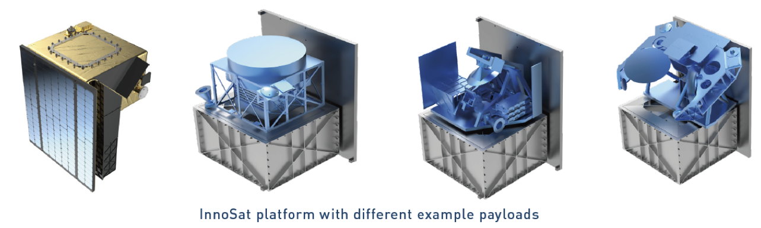
Fig. A-1. An example of instrument accommodation plan for the Swedish microsatellite for the Innosat platform (60 cm size with solar panel occupying one side).

Innosat design (compatibility with FACTORS)
There were several technological and logistic issues for Innosat to be considered as an extra spacecraft (cf. Sections 9, 12, 13). The FACTORS team, OHB-Sweden, SNSA, and Swedish experimental plasma community have already discussed these issues as listed below. With improvement of the Innosat capability that OHB-Sweden plans to implement for future Innosat (for marketing), many of these issues are already solved or can be solved within the constraint (mainly budget) of the SNSA's microsatellite program.

(1) Innosat will have small propulsion for attitude control and de-orbiting (dVs 100-200m/s with monopropulsion, or 200-400m/s with electric propulsion) but not enough propulsion to keep the formation flight or perigee maintenance (cf. Sections 9, 11, 12).
→ Solution: Keeping the formation fight with free-flying Innosat is solved by controlling FACTORS in both ∆V and in attitude (the latter adjusts the air drag). We have already made orbit calculation of formation flight including Innosat without propulsion, and confirmed that this is possible for 1-year operation, as shown in Fig. A-2. Inter-spacecraft distance can be kept <1.35 km if FACTORS makes maneuver every third day of ∆V= 0.0001-0.005 m/s (average 0.003 m/s each time; green line in the figure), and < 3.9 km for maneuver every fifth day of ∆V= 0.0001-0.007 m/s (average 0.004 m/s each time; blue line in the figure). Other options (every day and every other day) in Fig. A-2 are not practical.

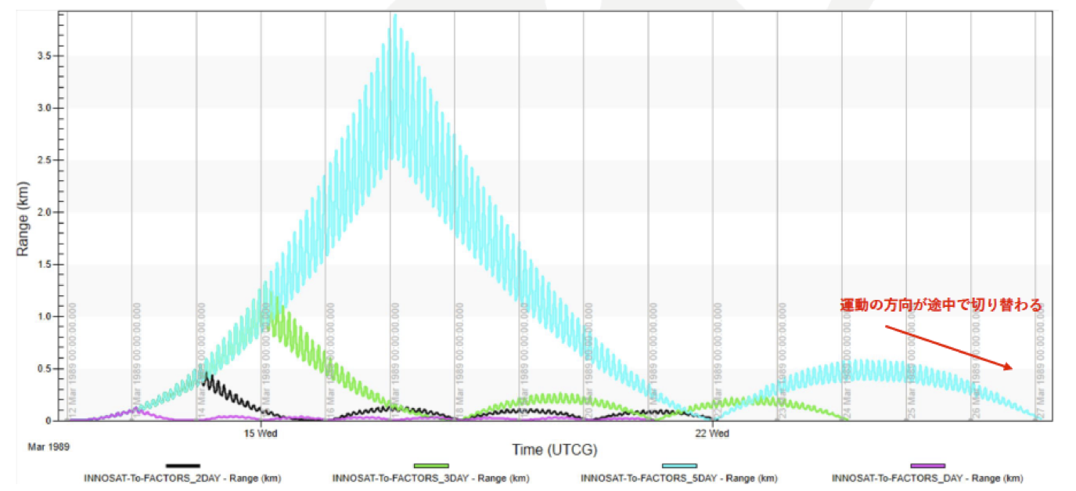
Fig. A-2. Inter-spacecraft distance between FACTORS and Innosat (for different options are shown for different frequency of orbit control of FACTORS).
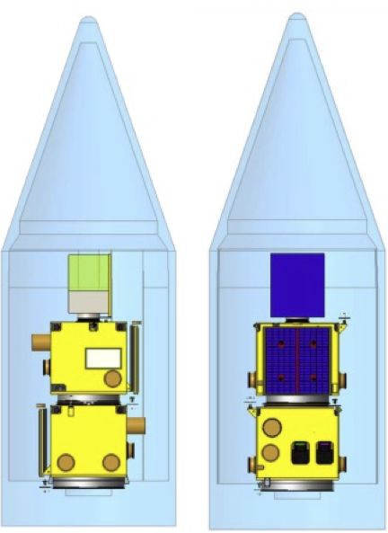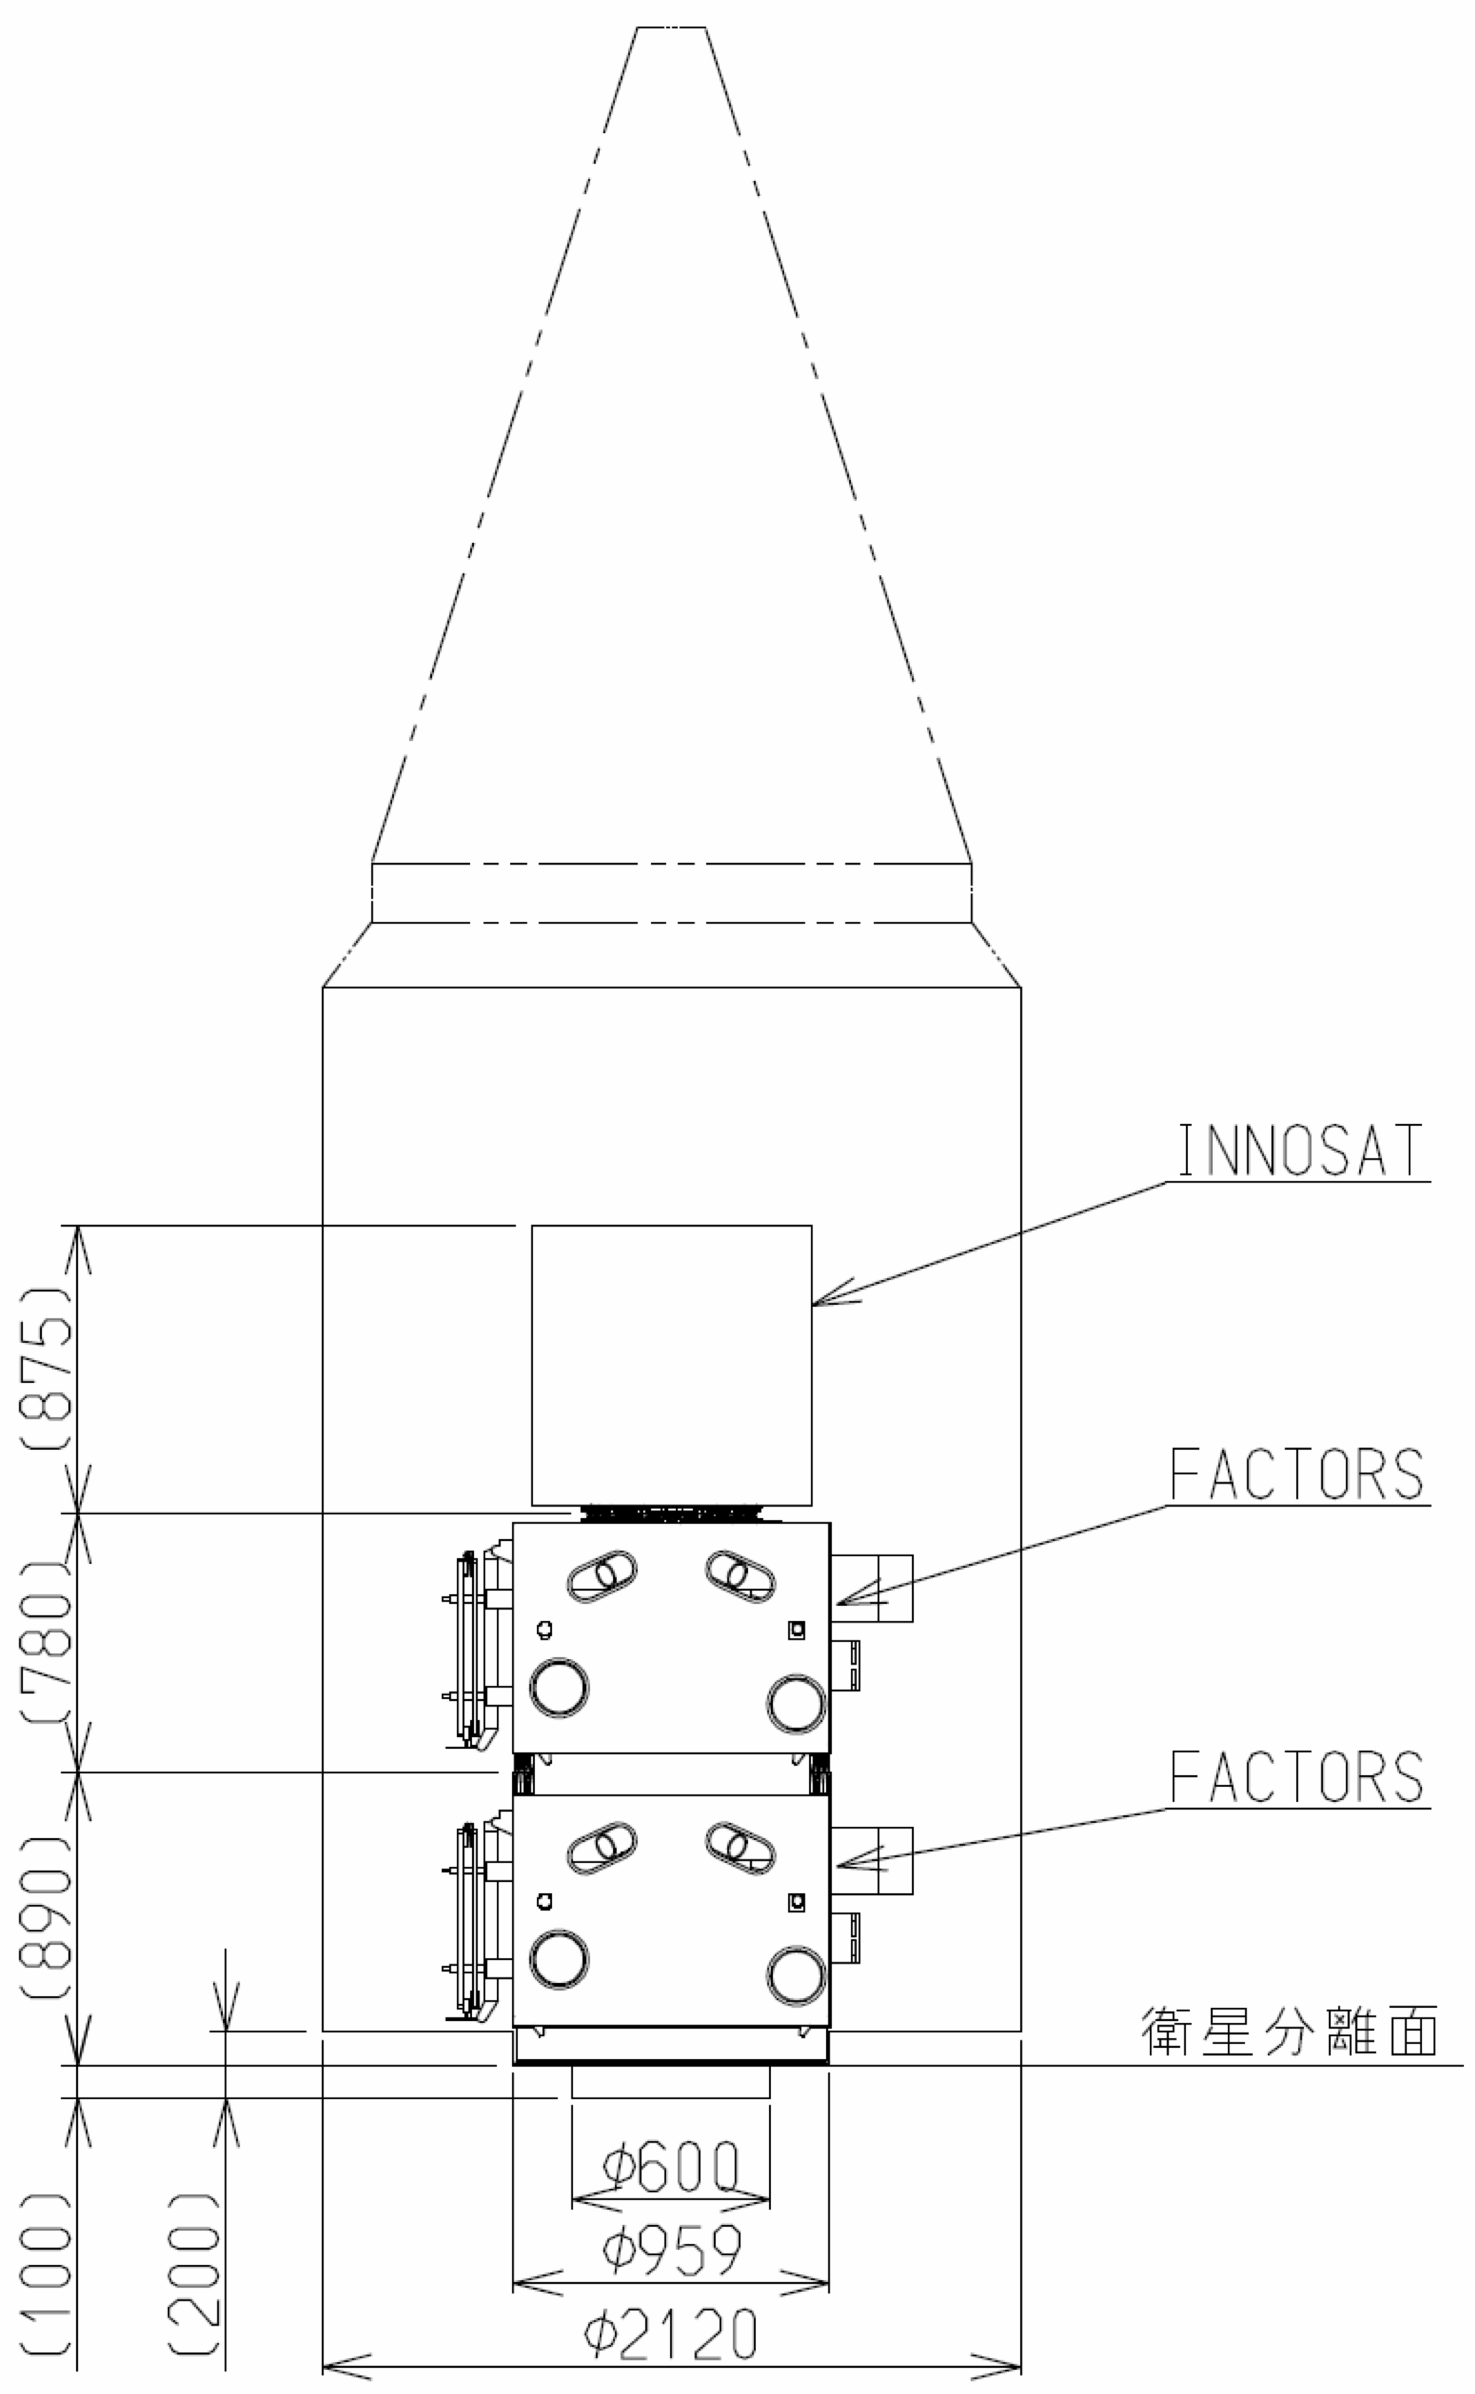
Fig. A-3. An example of fairing accommodating both FACTORS and Innosat, fitting to the Epsilon rocket.

(2) Innosat requires a cold launch (cf. Section 12.6).
→ Solution: For orbit insertion, no propulsion is required.

(3) Innosat must be squeezed into the payload fairing for the Epsilon rocket (cf. Section 12.6).
→ Solution: We have designed different options and confirmed that this is possible. Fig. A-3 shows one example. The best option will be decided during pre-phase/phase-A study.

(4) Original Innosat does not have counter-radiation treatment (< 15 krad component for some case) because of 500 km circular orbit, while FACTORS orbit predicts 1-year dose is about 70-100 krad after 2 mm Aluminum (cf. Section 12.3).
→ Solution: Since our payload is much less than 15 kg, extra shielding is possible for higher apogee than the original apogee of 500 km.

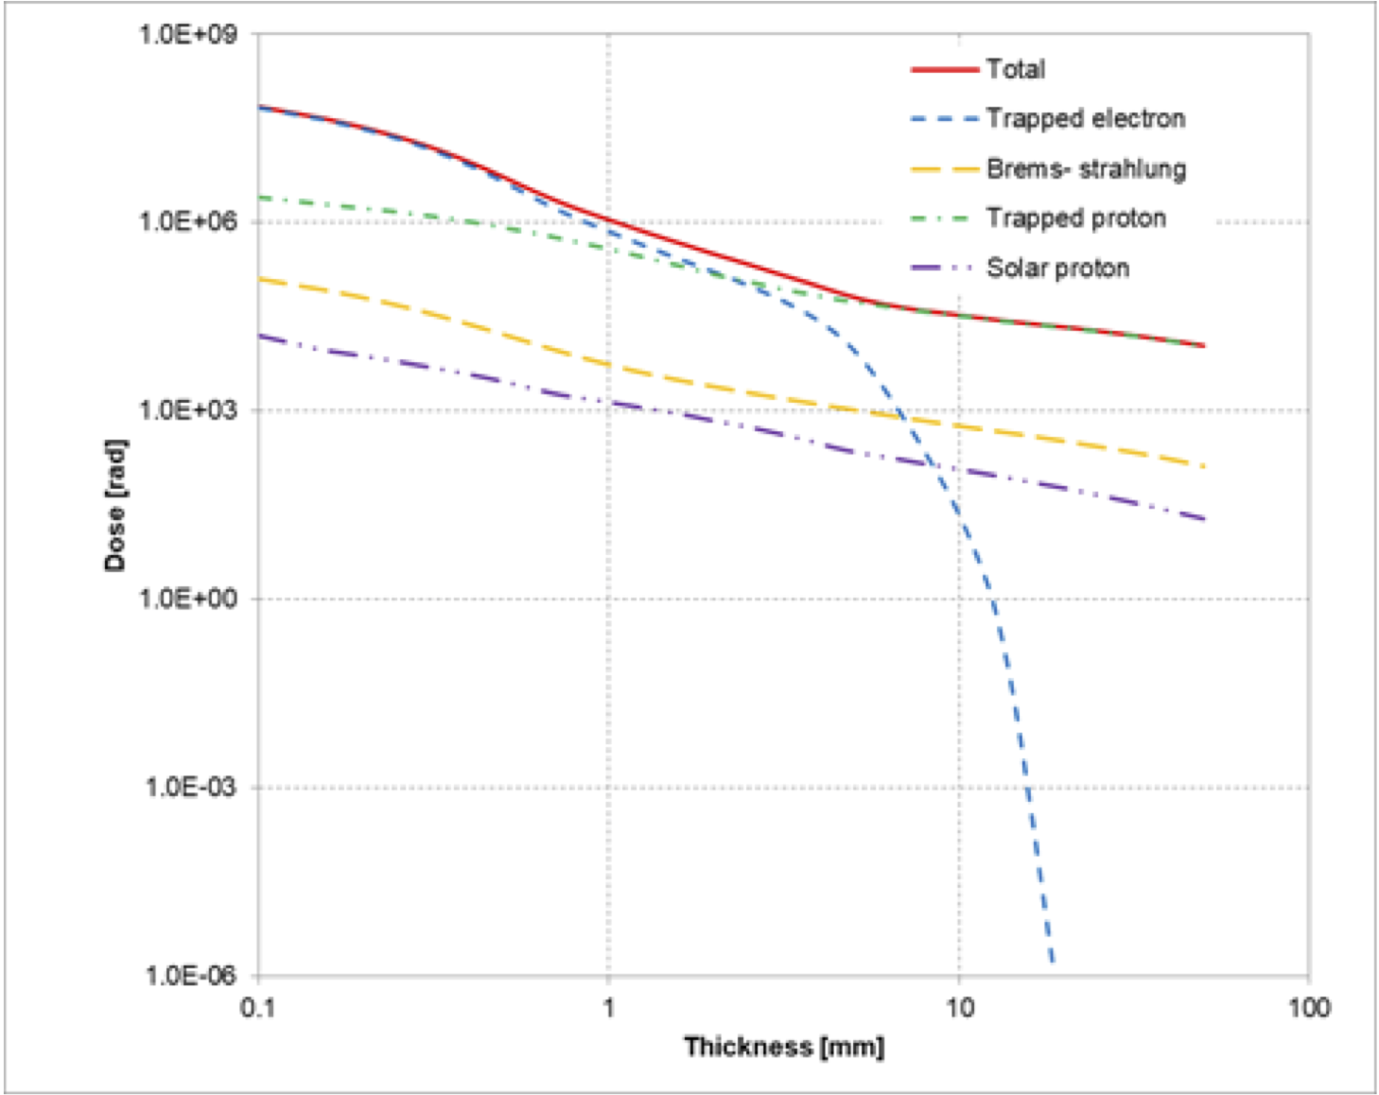
Fig. A-4. Expected total dose for different Aluminum shielding.

(5) Airdrag of FACTORS orbit (perigee 350 km) is much higher than circular 500 km orbit, and Innosat without propulsion might not keeps its altitude very long (cf. Section 12.3).
→ Solution: We start from slightly higher altitude than 350 km (e.g., 400 km) for the initial perigee altitude such that science operation is kept around 350 km for perigee. This gives Innosat sufficient lifetime for its science. Since this is a bonus spacecraft for FACTORS mission, it is quite ok that the formation flight with three spacecraft much less than one year, which formation flight with two main spacecraft is kept more than one year.

(6) Original Innosat is manufactured for dawn-dusk orbits without eclipse. However, FACTORS noon-night orbit experiences substantial eclipse with maximum duration about 40-90 minutes (45 min for 350km x 3500 km with 75-90° inclination). Therefore, Innosat must survive the eclipse (cf. Section 9).
→ Solution: OHB Sweden plans have a buttery to enhance the Innosat capability for orbits at other meridians with short eclipse. Furthermore, no science operation is planned during eclipse (therefore, launch window is made such that initial apogee will be placed in the dayside).

(7) We need to monitor the inter-spacecraft distance (cf. Section 12.8).
→ Solution: GPS method of distance control (OHB-Sweden has experience with technological formation flight mission PRISMA in 2010) can easily achieve 1 km inter-spacecraft separation with positioning accuracy of 100 m.

(8) Are operation and telemetry of Innosat together with or separately from FACTORS main spacecraft? (cf. Sections 7.4, 9)
→ Solution. Innosat agreed to have plan the same transmission system as FACTORS such that the same ground station can be used simultaneously in a effect way (Lightband transmitter is provided by ISAS). However, we plan independent operation between Innosat and FACTORS because Innosat does not have propulsion for orbit control (no need for coordination). On the other hand, science operation plan, which is made by scientists, can be coordinated such that observation mode is coordinated.

(9) How can we make data system in most efficient manner? (cf. Section 7.4)
→ Solution: Because of much less total amount of data, Innosat can perform fast download (S-band 5 Mbps/X-band >100Mbps), allowing the same temporal resolution as the main FACTORS spacecraft. Therefore, when treating the data on ground, data from all spacecraft are treated equally.

(10) Do we have inter-spacecraft communication system (cf. Section 6)
→ Solution: No need. The inter-spacecraft communication is useful only if we implement an autonomy system to protect switch off the payload using radiation monitor (e.g., energetic particle instruments on the FACTORS), such that the same acute switch off is applied to Innosat too.

(11) Innosat is three-axis stabilized and this matches with FACTORS, but spin stabilized platform increases science output third satellite and Swedish payload.
→ Solution: Nominal is three-axis stabilized, and spin stabilized method will be discussed during phase-0 study of Swedish microsatellite proposal as a possible alternative.

Logistic issue for Swedish microsatellite fitting into FACTORS
There were also logistic issues for Innosat to fly with FACTORS

(12) Having international collaboration (formation flight) in proposal does not give bonus in the evaluation of Swedish microsatellite proposals.
→ Solution: Science value of the Swedish microsatellite as one of the formation flight fleet is very strong and free launch of this microsatellite will cancel the extra cost for Innosat side when flying the requested orbit.

(13) Swedish microsatellite program assumes maximum ~4 year project time from proposal submission to the launch, and SNSA does not accept proposal with longer project time, although SNSA allows delay of launch after the project starts. If the Swedish microsatellite is be an official fleet of FACTORS, JAXA-SNSA agreement must be issued by the timing of MDR/SDR of FACTORS (this need negotiation), but that time the FACTORS-related Swedish microsatellite must be selected.
→ Solutions: As mentioned above, SNSA most likely considers the timing of AO such that it fit to the FACTORS project. While head of ISAS solar system plasma group (FACTORS lead) with negotiate with SNSA about this 4-year duration, the Swedish microsatellite can also be treated as simple piggyback of FACTORS because the FACTORS design is not affected by the Swedish microsatellite. In this way, Swedish microsatellite can be proposed even during phase B study of FACTORS, making the mass margin for launch is more well known.

Extra cost for FACTORS by adding Swedish microsatellite (cf. Section 16)
Manufacture (including test) and operation of Swedish microsatellite are performed by Swedish side under SNSA microsatellite program. Therefore, the extra cost for the FACTORS side (as listed in Table A-2) is about 100 million JPY, which is included in the budge margin for FACTORS.

Table A-2. The source of the extra cost by having the third spacecraft.
- Various tests if the tests require both FACTORS and Swedish microsatellite (e.g., vibration test)
- Works at the launch site (Uchinoura)
- Launch (fairing, separation etc).
- Lightband
- Extra component (e.g., radiation-proof) if the orbit apogee is very high
- Extra propulsion if orbit control is required
- Electron spectrometer, if possible (this can be provided by the third country, though)

