

DIAS D4.1
Server Prototype

University of Athens,
Department of Informatics & Telecommunication

Mihalis Hatzopoulos
Yannis Ioannidis
Natalia Manola
Vassilis Stoumpos
Antonis Lebessis
Marios Trivizas

Blustaff

Valentino Sarli
Stefano Gasperini
Alessandro Zanchi

Contributing institutions: NOA, INGV, RAL, IAP, SRC, IRF

Table of Contents
1 Introduction 3
2 Products – Services 3
2.1 Ionograms 3
2.2 Ionospheric Maps 4
2.2.1 foF2 & M(3000)F2 maps 4
2.2.2 MUF maps (under development) 6
2.2.3 Electron Density Maps (under development) 6
2.3 Plots 6
2.4 Alerts (under development) 8
2.5 Historical Data (under development) 8
3 DIAS server architecture 9
4 Miscellaneous 10

Introduction
The purpose of the DIAS server is to provide value added products and services of a European digital data collection on the upper atmosphere. The definition of these products is derived by the user needs, and driven by the research in the field. In the first section of this document, we present a description of the all the functionalities provided, focusing on the ones that have already been implemented for the prototype. In the last section we give a short description of the internal architecture of the system and the technologies used.
For the prototype DIAS server, the data is contributed by the following ionosonde stations:
Ionosonde Station name | Location | Acronym
National Observatory of Athens, Greece | Athens | NOA
Rutherford Appleton Laboratory | Chilton | CCLRC
Leibniz Institute of Atmospheric Physics | Juliusruh | IAP
National Institute of geophysics & volcanology | Rome | INGV
Swedish Institute of Space Physics | Lycksele | IRF
Space Research Centre, Polish Academy of Sciences | Warsaw | SRC
Ebro Observatory | Ebro | Ebre
Institute of Atmospheric Physics, Czech Republic | Pruhonice | UFA

Products – Services

Ionograms
Ionograms are generated by DIAS as soon as the participating stations complete their soundings and the data is collected, based on a 15 min interval. For a consistent and harmonized look, ionograms from different stations are plotted with homogeneous characteristics. As a result, users are able to easily compare ionospheric conditions over different areas in Europe:
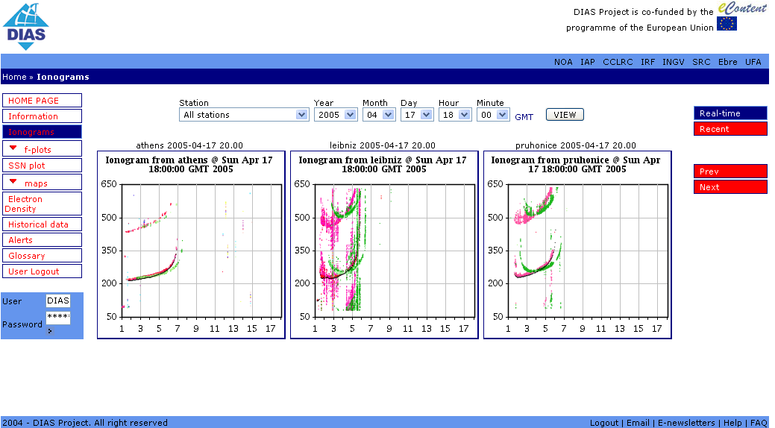
Figure 1 Real-time Ionograms provided by the DIAS Server
Depending on the sounding equipment/hardware used, the participating stations provide the ionogram data primarily in two formats:
- Digisonde: this data format has gone through three recent updates, and consequently the system must be able to support all these sub-flavours. Currently, DIAS is working only with the latest two versions (NOA-Athens & IAP-Juliusruh are already supporting these, INGV-Rome & SRC-Warsaw will support them in the near future). An implementation of the earlier format is within the DIAS plans, scheduled by the end of the project (CCRLC-Chilton).
- Dynasonde: the main difference of this format is that it does not enclose any transformations on the sounding measurements. IRF-Lycksele is currently the only participating station using this equipment. It is within DIAS’ next six months' plans to support this format.
In this prototype version of the DIAS server, only the NOA-Athens, IAP-Juliusruh and UFA-Prohonice ionograms are displayed.
How to navigate: By selecting the Ionograms item in the navigation menu, you can select a view of the latest ionograms, from a list of stations (one or all). In the next screen you can make a selection for a different station and/or time/date.
The functionality of the buttons on the right
Real-time | to view the latest ionogram(s)
Recent | to view the eight (8) most recent ionogram for the selected station
Prev & Next | to view the previous or next ionogram for the selected station in chronological order
Note: On the upper right hand corner the ___km, ___MHz, ___Density fields are scheduled to be filled with values of the height, frequency, and density (up to the height of maximum ionisation), which correspond to mouse movement over the ionogram.

Ionospheric Maps

foF2 & M(3000)F2 maps
DIAS offers nowcast, short-term and long-term forecast maps of foF2 and M(3000)F2 over Europe. Data is currently contributed by the following stations: IAP-Juliusruh, IRF-Lycksele, NOA-Athens, CCRLC-Chilton, UFA-Pruhonice & Ebre Observatory. The INGV-Rome and SRC-Warsaw stations will contribute data as soon as their stations are in full operation.
- Nowcast Maps: Given the observed values of foF2 and M(3000)F2 from participating stations, a best fit algorithm (Improved SIRM: Simplified Ionospheric Regional Model) is applied, and maps of the ionospheric conditions over Europe are generated. These maps are generated on a 15 minute interval.
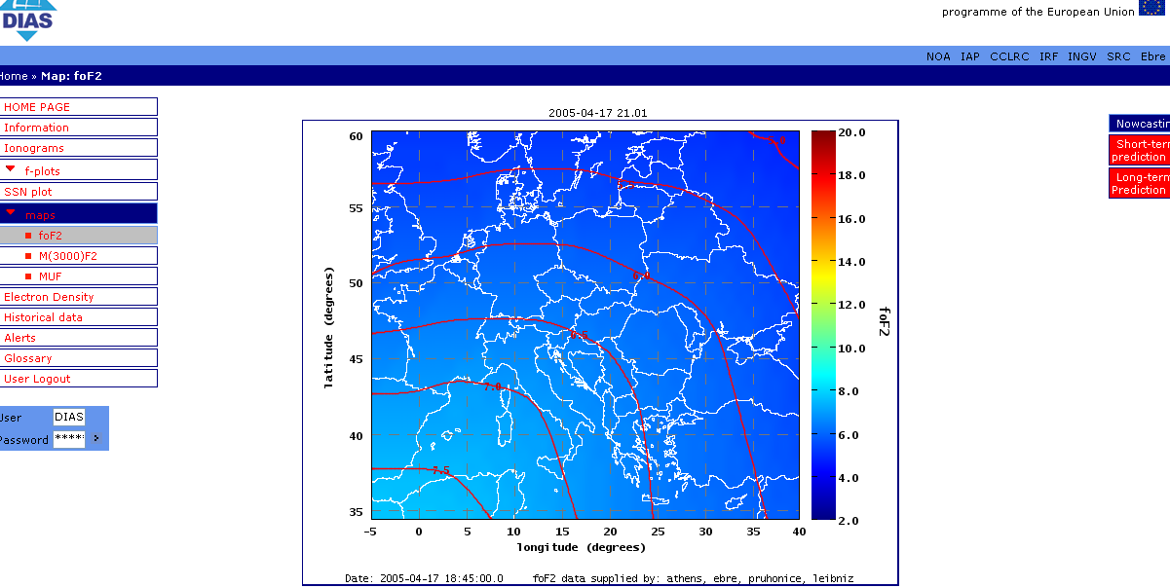
Figure 2 foF2 nowcast over Europe
- Long-term forecasts: Given the predicted value of the sunspot number, published by SIDC of Belgium World Data Center, DIAS generates 24 forecast maps for the current month, one for each hour within the day. The functionality of the server will be enhanced so that up to three (3) months' forecasts can be provided.
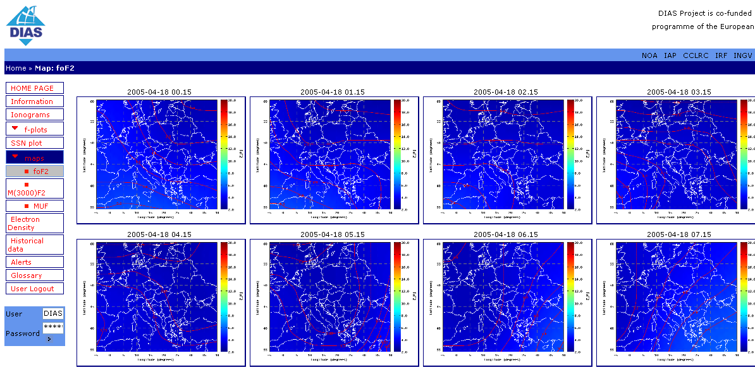
Figure 3 foF2 long term forecasting over Europe for the current month
- Short-term forecasts for foF2 (ONLY) (under development): Given the recent values of foF2 from previous soundings, and historical data on geomagnetic activity for each station, the “GCAM - Geomagnetically Correlated Auto Regression” model by Kutiev, Muhtarov & Cander, is applied and generates the next 24 hours’ ionospheric conditions over Europe.
How to navigate: By selecting the “Map: foF2” or “Map: M(3000)F2” item in the navigation menu, you will immediately view the latest nowcast map. On the bottom caption of the map you can see which stations contributed to the generation of the map.
The functionality of the buttons on the right
Nowcasting | to view the latest map
Short Term Prediction | (foF2 only) to view the short-term forecasting maps (under development)
Long Term Prediction | to view the 24 long-term forecast maps of the current month, one for each time within the day
Note: On the upper right hand corner the ___Latitude, ___Longitude, ___MHz fields are scheduled to be filled with values of the coordinates on the map, and the value of foF2, which correspond to mouse movement over the map.

MUF maps (under development)
The DIAS server has been designed taking into consideration the generation of MUF maps (both nowcasts and long term forecasts). They are scheduled to be produced on an hourly basis, with a selection of major cities of Europe regarded as the central, transmitting points.
Future services may also include on demand MUF map generation, assigning any site in Europe as the transmitting point.

Electron Density Maps (under development)
The DIAS server will be able to generate nowcast maps of electron density over Europe, based on scaled data from soundings (Stanislawska et al., 2000, 2001 & Leitinger et al., 2002). The results will be presented in the following ways:
- isoline maps for predefined heights of 100, 200, 300 km (or up to the F2 height). Maps with smaller height resolution (10 km) will be produced on demand (considered one of the added value services).
- graph of height/density over a particular station
The map generation interval will be 15 min.

Plots
DIAS offers daily plots of the main characteristics of the incoming soundings. Again, the data is currently contributed by the following stations: IAP-Juliusruh, IRF-Lycksele, NOA-Athens, CCRLC-Chilton, UFA-Pruhonice & Ebre Observatory. The INGV-Rome and SRC-Warsaw stations will contribute data as soon as their stations are in full operation.
- foF2 observed values for each station
- fmin observed values for each station
- foF2 long-term predicted values (f_{SIRM}) for each station
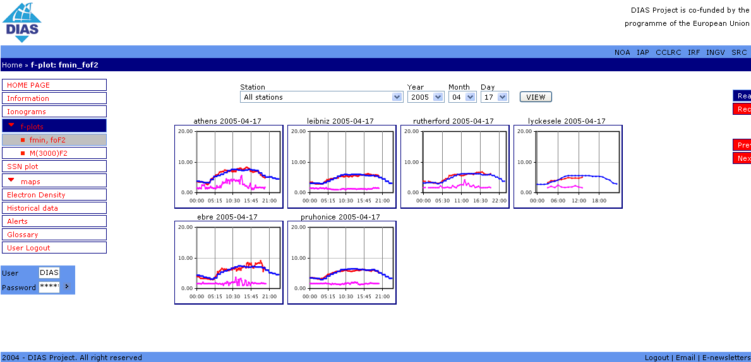
Figure 4 Daily foF2, fmin, f(SIRM) plots of all stations
- M(3000)F2 observed values for a station
- M(3000)F2 long-term predicted values for a station [M(3000)F2_{sirm}]
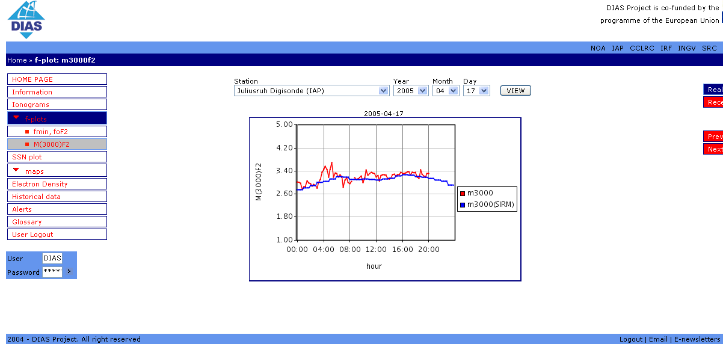
Figure 5 M(3000)F2 daily plot from Juliusruh
- R_{eff}, effective Sun Spot Number (SSN) over Europe
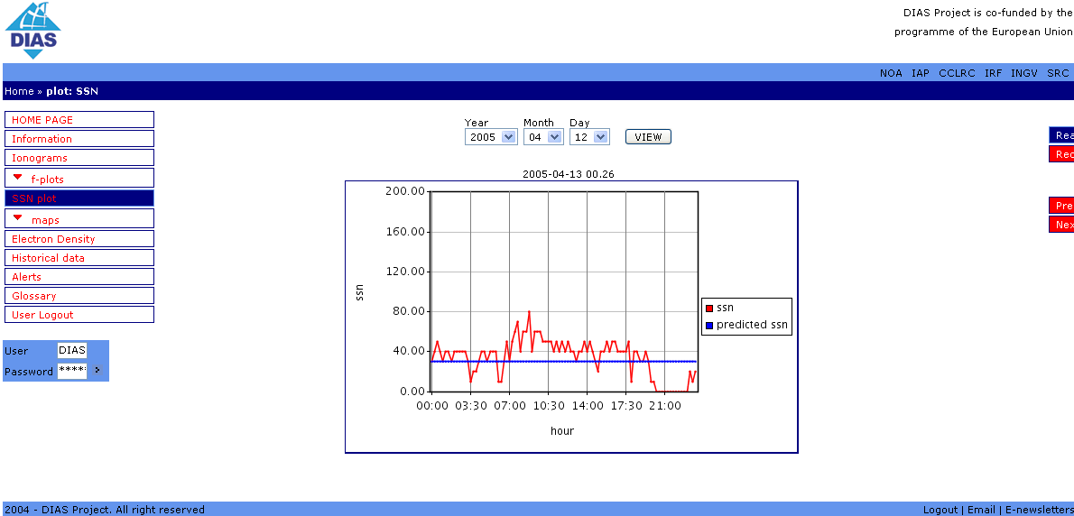
Figure 6 Reff over Europe for 12-04-2005
Short-term daily forecast plots of foF2 are under development. This service will tie in with the completion of the short-term forecast product.
How to navigate: By selecting the “f-plots: foF2,fmin” or “f-plots: M(3000)F2” or “SSN plot” item in the navigation menu, you can view the latest plots of the selected station(s). On the next screen you can pick another date and/or station to view.
The functionality of the buttons on the right
Real-time | to view the latest plot
Recent | to view the eight (8) most recent plots
Prev & Next | to view previous or next day's plots
Note: On the upper right hand corner the ___Time, ___MHz fields are scheduled to be filled with values of the time and the value of foF2/fmin/M(3000)F2, which correspond to mouse movement over the plot.

Alerts (under development)
The service of issuing ionospheric alerts is one of the main DIAS products and will essentially consist of the following characteristics:
The simple alerts concerning short term foF2 and M(3000)F2 predictions will be posted on the DIAS web site for all users.
In parallel, a user subscription service will be maintained, with registered users being able to enter personalized criteria for various parameters. DIAS will be capable of dispatching the appropriate alerts either via email or SMS messages.

Historical Data (under development)
One other functionality that DIAS will be offering to its users, relates to the dissemination of the data that is available to the system. Here are some examples of data that users might be interested in:
- scaled information stored in the system database (for instance, values of foF2 for a particular station over a period of time)
- raw files (SAO, RSF, etc.) that DIAS is collecting from individual stations (if authorization from the corresponding station is granted)
- data produced by the services/products of the system (images, plots, maps, variable values) both in image and textual form
Again, a user subscription service will be maintained, with registered users being able to enter personalized criteria for periodic data downloads. DIAS will be sending out the data using HTTP/FTP protocols.

DIAS server architecture
In this section we provide a short description of the internal architecture of the DIAS server. The following figure displays the layers which form the system, together with their subcomponents.
FTP / HTTP protocols
IAP

Ebre
RAL
IRF
NOA
SRC
INGV
UFA
Ionosonde Stations
DIAS backbone Server
Other Value added Products
One for each station
File Collector
SIRM Generator
Station Monitor
DIAS storage
Monitors all stations traffic
Filesystem
& Database
Ionogram Generator
SBF
RSF
Dynasonde
Generates ionogram image
Data Monitor
SAO
Stores Scaled Data
foF2 & M(3000)F2 Plot Generator
R_{eff} Plot Generator
Stores resulting Data
Stores Files Location
UoA Request Broker
Request User Interface Manager
xBrick
Request/Respond Protocol (Java RMI)
Web Server
Web Interface

Figure 7 Internal DIAS architecture

Ionosonde Stations layer: The participating stations continue to operate autonomously, having the additional task of placing the sounding data on one or more predefined FTP or HTTP servers.

DIAS Backbone Server layer: The File Collector is the subcomponent responsible for collecting the data from the repository locations, as well as for triggering a number of tasks inside the DIAS server. As soon as a file is collected, the corresponding file location is stored into the system database (Station Monitor), and depending on the type of the file the appropriate task is activated. In the case of raw ionogram data, the Ionogram Generator module creates the ionogram images and stores the newly created files into the system database. If files containing scaled data (SAO) are coming in, then the Data Monitor is activated, initially storing the parameters in the database, and, subsequently calling the subcomponents responsible for the production of nowcast/forecast maps (SIRM Generator) and daily plots (foF2 / M(3000)F2 Plot, R_{eff} Plot Generator). Any additional value added products will similarly be set off from this location.

Web Interface layer: This layer is divided into two main parts. The first one is associated to the functionality offered to the users, as well as the aesthetics of the site. It is built on top of a web server engine and communicates to the DIAS backbone server layer via the DIAS Request Broker subcomponent.

Miscellaneous
The DIAS server and its web interface were built using state of the art technology and tools:
Operating system: Linux
Database technology: MySql
Web server: Tomcat
Tools: Apache Torque, Ant, Java 1.4 & 1.5
Other: proprietary web development framework xBrick

DIAS prototype server URL: http://213.203.172.83:8080/dias/servlet/dias.servlet.DIASLogonFormServlet

Finally, we must emphasize that all user assessment is expected to come on line via the Contact Us link on the bottom bar found in all pages. Moreover, a link is provided to the DIAS project Newsletter at the same location.

