Principles for getting useful frequencies for HF communications over known distances – the old way
DIAS gives data in the form of maps, pictures and numerically in ASCII format. Mostly foF2 and MUF are considered. For HF-communication between two stations the parameter foF2 gives the highest possible frequency for very short distances (in theory zero distance) between the two stations and the parameter muf(<a distance>) gives the highest possible frequency for a very long distance. But how will it be for distances in between?

The above-mentioned data can certainly be used with the help of some extra know-how, but more detailed data are available from DIAS. These include sequences of pairs of numbers for given virtual heights and corresponding frequencies, different kind of traces, which could give more accurate results! So it is possible in DIAS to get an idea of which frequency is the best to use for communication between two given places.

In the old days one could proceed as follows to solve the problem;

Please look at the figure below, from “The Swedish Ionosondes”.

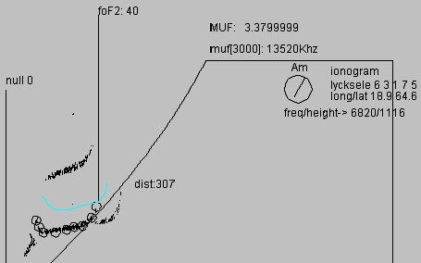

An ionogram is shown together with the two parameters, foF2 and muf(3000). A coloured curve is also shown, which indicates a calculated result from a virtual oblique sounding over a 307 km long distance (this distance can be freely selected by the user). Oblique sounding means transmitting from one place to another a distance away. The highest frequency for the oblique sounding can be seen to be a little bit higher than foF2. The muf(3000) indicates the highest frequency for a sounding over 3000 km and one can see that the frequencies for our oblique sounding are lower than the muf(3000).

The circles are mark selected points on a trace in the ionogram. These points have been selected manually and the calculation of the virtual oblique sounding is made from these points. In DIAS, corresponding values are automatically selected from the sounding and included in the data, which are in SAO format, a standard for ionogram data. Some people nowadays think of this data as the primary data from which ionograms are drawn.
An ionogram is then a second hand created picture, but in the old days it was the other way around! With a simple calculation it is then possible to get a rough estimate of the ordinary trace for an oblique sounding from the ordinary trace for a vertical sounding. In our case the distance is 307 km. With help of the mouse one can then go around in the modified picture of the ionogram and catch the frequency to be used!
In the figure below an oblique sounding is illustrated for a distance of 1026 km.

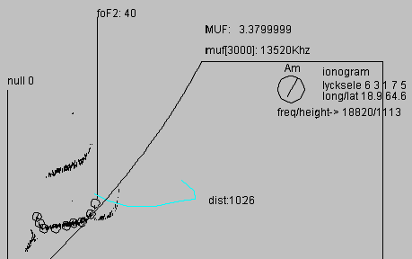
From these two hypothetical-theoretical experiments we can see that it is possible to get a better idea of which frequency is the best to be used, when the distance between the transmitter and receiver is known.

The pictures are taken from sessions for the Swedish Ionosondes at
http://www.irf.se/~ionogram/ionogram/javascaling/viewScaled.html

It is important to note that the sessions in question are interactive and very sketchy and one has to manually create the numerical data for the ordinary trace from the picture of the ionogram, which is the primary data in this old fashionable system.

One question is evident “Don’t we need several vertical sounding stations to make frequency estimates for transmitting over distances?”
The answer is yes, and DIAS’s main goal is to use data from several stations when solving different problems regarding the upper atmosphere over Europe.
See next section, 4.4

Getting useful frequencies for HF communications over known distances, a special service in DIAS
Please find a rough sketch how to use DIAS data in this case.
Assume we are interested in transmitting from Karlskrona in Sweden to London in England at 14 September 2005 at 1500 UT.

Look at the MUF map below with Athens as the transmitting point. The distance between Karlskrona and London is equal to the distance between Athens and Sardinia. From the MUF map we get the maximum frequency to 10MHz for transmitting between Athens and Sardinia.

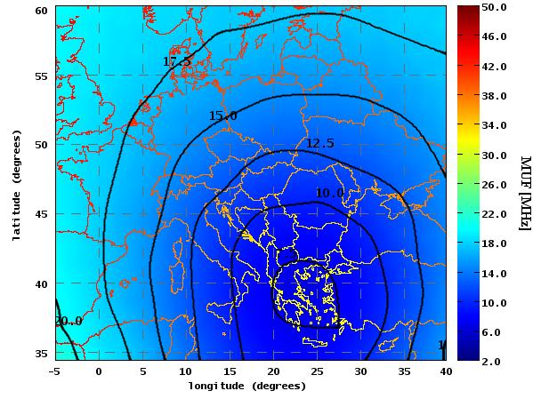
Fig. 41: MUF map with the transmitting point at Athens at 14 September 2005 at 1500 UT

Choose the foF2 map over Europe:

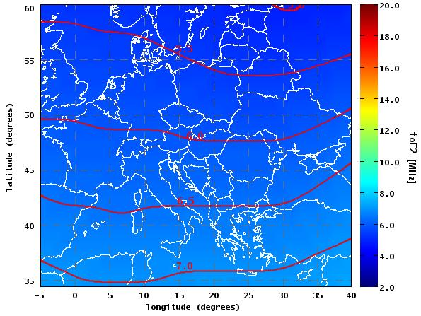

Fig. 42: foF2 map over Europe at 14 September 2005 at 1500 UT

We can see that foF2 is about 5.5 at the place for transmitting and 6.7 between Athens and Sardinia, the reference place.
Finally choose the M(3000)F2 map over Europe and find that the muf factor is about the 3.4 at the two places, the same!

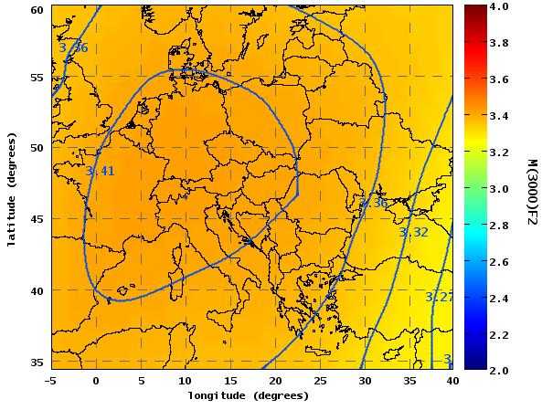

Fig. 43: M(3000)F2 map at 14 September 2005 at 1500 UT

So we take the maximum usable frequency for our transmitting to be 5.5*(10/6.7) ~ 8MHz, using linear calculations.
(10/6.7) is the M(distance Athens Sardinia). The two M(3000) is equal according the maps and we therefore assume the M(distance Athens Sardinia) is equal M(distance Karlskrona London).
This was a little bit technical complicated, but in DIAS we can get it easier with the following session:

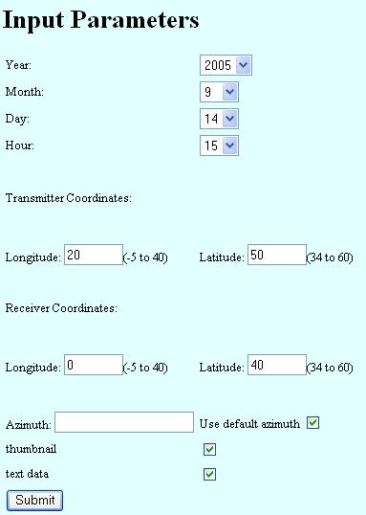

Result:

2005/09/14 @ 15:00 UT
Transmiter=50.0/20.0 Receiver=40.0/0.0
MUF(Transmitter,Receiver)=10 Mhz

Fig. 44: Quick session in DIAS to get MUF between two points

