


Contact:
Project coordinator: Dr Anna Belehaki
belehaki@space.noa.gr
http://www.iono.noa.gr/DIAS/
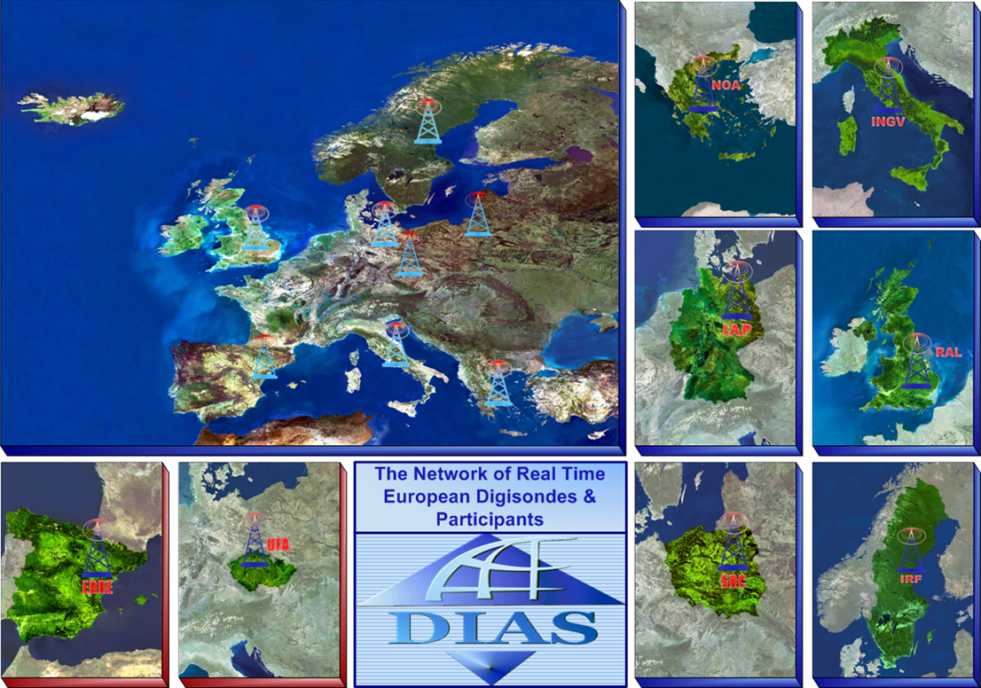

Manual

European DIgital Upper Atmosphere Server, DIAS

