The DIAS questionnaire is ready for use. It consists of four parts, triggered sequentially, as four web pages,
http://www.iono.noa.gr/DIAS/QUESTIONNAIRE/part1.cfm
http://www.iono.noa.gr/DIAS/QUESTIONNAIRE/part2.cfm
http://www.iono.noa.gr/DIAS/QUESTIONNAIRE/part3.cfm
http://www.iono.noa.gr/DIAS/QUESTIONNAIRE/part4.cfm

At the moment it is accessible from the DIAS home page, by means of a new button:

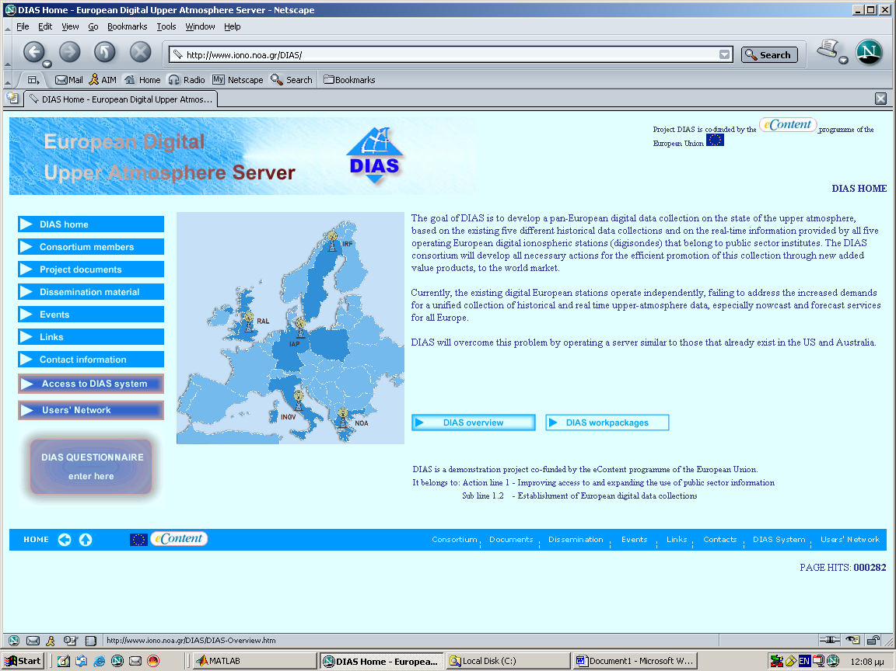

When the new button is pressed, it loads the questionnaire onto a new window. Users may quit at any point; any information they entered, whether complete or not, is stored in a database.

To add the facility on your web pages, we are sending you:
- The animated GIF file quest_button.gif.
- The HTML code behind the button:

<a href="javascript:StartQuest()"><img border="0" align="absmiddle" src="http://www.iono.noa.gr/DIAS/quest_button.gif"></a>

- The JAVASCRIPT called up by the anchor:

function StartQuest() {
window.open("http://www.iono.noa.gr/DIAS/QUESTIONNAIRE/part1.cfm","QUESTIONNAIRE","toolbar=no,location=no,directories=no,status=no,menubar=no,scrollbars=yes,resizeable=yes,WIDTH=850,HEIGHT=750"); }

To use
1. Copy the GIF file in a location accessible by your site
2. Place the HTML code in your page’s source-code
3. Add the JAVASCRIPT at the start of the same page.

