EDUCATION 040910

AUSTRALIA and USA

http://spidr2.ips.gov.au/spidr
http://spidr.ngdc.noaa.gov/spidr/

SPIDR, Space Physics Interactive Data Resource, is a tool for the user to interactively search, browse, and access space weather datasets.
Description of what SPIDR is and how data can be manipulated and delivered (baskets, a collection of different space weather parameters selected from different databases for the same time interval).
(Each SPIDR node has a database management interface, which allows data updates performed either by a local user or by another SPIDR server from the Net. The servers communicate with each other for scheduled mirroring of the data and software.)

Separate help window (you don’t need to register or log in to use this help) where there is an introduction of the ionosphere, explanation of what the ionosphere is and what the ionization depends on.
(They also mention that in some circles it is thought that the ionosphere can be used as a predictor for large earthquakes.)

There is an explanation of what ionograms are; about signals and radio pulses. There are also explanation of virtual height, critical frequencies and how ionograms can be scaled.

Definitions of the ionospheric regions and of what height they occur.

IIWG (Ionospheric Informatic Working Group) Data Exchange Format is described.

URSI (The International Union of Radio Science) Qualifying and Descriptive letters are explained.

All ionospheric vertical incidence parameters are shown and described.

To use the program you need to register and log in.
After logging in you don’t get any further help or education. It is the same help window as before. To manage the program it is enough.
Information is short and easy to read through.

AUSTRALIA

http://www.ips.gov.au

Educational/Other topics/Radio Communication/Introduction to HF Radio Propagation
In this PDF-document everything about radio communication is described.
Good descriptions with a lot of images for better understanding.
Headlines:
1. The Ionosphere
Regions
Picture:
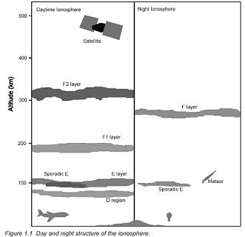

Production and loss of electrons
Observing the Ionosphere
Ionospheric variations
Variations in absorption
Sporadic E
Picture:
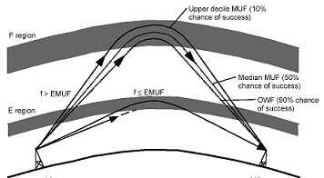

Spread F
2. HF Communication
Types of HF Propagation
Hop lengths
Propagations modes
E layer screening
Frequency, range and elevation angle
Skip zones
Fading
Noise
VHF and 27 MHz propagation
Medium frequency sky wave propagation
Universal time
3. Summary of the effects of Solar disturbances
Short wave fade-outs
Polar cap absorption events

Educational/Other topics/Radio Communication/Transequatorial Radio Propagation
Information about transequatorial propagation and the Equatorial Ionosphere.

Educational/Other topics/Radio Communication/T Index FAQ
Explanation of what T Index is and how it is used (necessary when using the prediction tools.). Rather easy to understand.

USA

http://www.ngdc.noaa.gov/stp/IONO/Dynasonde/

http://www.ngdc.noaa.gov/stp/IONO/Dynasonde/whatis.htm

Explanation of what an ionosonde, ionograms, digital ionosonde, digital ionograms and a dynasonde are. It is clear information and easy to understand.

Links to external sites, for example:
http://ulcar.uml.edu/framesd.htm (digisonde)
http://www.ngdc.noaa.gov/stp/IONO/Dynasonde/history.htm (history of the dynasonde)
http://www.ngdc.noaa.gov/stp/IONO/Dynasonde/future.htm (the future of the dynasonde)
http://www.ciw.edu/DTM-history-75years.html (measuring the height of the ionosphere in 1925)
http://www.ips.gov.au/IPSHosted/INAG/web-62/ionoso~1.htm (ionosonde antennas)

http://www.ngdc.noaa.gov/stp/IONO/Dynasonde/tutorial/tutorial.html
Some headlines:
Pulsets and echo recognition
Information content of a pulset
Higher level of Dynasonde data analysis
Upper part of the ionogram presentation
Lower part of the ionogram presentation

http://www.ngdc.noaa.gov/education/education.html
Different links to educational resources, for example:
Climate Timeline Information
Earth Magnetics
Geomagnetic Field FAQ //Added since version 2
Ex. “What is the Earth’s magnetic field?” etc. //Added since version 2
Glossary of solar-terrestrial terms
National Snow & Ice Data Center
Material for download

No information of Ionosphere, ionograms etc.

http://www.ngdc.noaa.gov/stp/IONO/ionohome.html
Information about the Ionospheric Physics Group
Links to locations with ionosphere data archives
Real-time ionospheric fOF2 data from SEC in Boulder
SPIDR online data access & plots ( http://spidr.ngdc.noaa.gov )
Glossary of solar-terrestrial terms
Interesting ionosphere links
Ionosphere related models
TEC (total electron content) maps from the IRI model
Introduction to the ionosphere
The same information as on http://spidr.ngdc.noaa.gov/spidr/
Vertical incidence soundings (ionograms)
The same information as on http://spidr.ngdc.noaa.gov/spidr/
Definition of structure (the ionospheric regions)
The same information as on http://spidr.ngdc.noaa.gov/spidr/
History of vertical ionospheric soundings
Catatlog of characteristics
Ionosphere related models
Ionospheric indices
Definitions of indices (R12, IF2, IG, T) //Added
Space Weather Indicies
Plots of daily indices //Added
Smoothed Sunspot Number Data (1957 – 1999)
Realtime Effective Sunspot Number (bases on foF2)
IF2 & IG
WDC Data, models and other facilities //Added
Ionospheric indices sample page
HF radio interest
Links to:
Millstone Hill observatory home page
Hiraiso Solar terrestrial research center/crl

http://www.sel.noaa.gov/
Space environment center
The official source of space weather alerts, warnings and forecasts.
Links to:
Space weather now
Online data
Education
Customer services
SEC projects

http://www.sel.noaa.gov/Education/
Nice site with lots of information, descriptions and explanations!

Here there is information about following:

Space weather information
Solar effects
Space weather operations
Solar cycles
Solar terrestrial effects
Earth-space activities disrupted by solar events
Frequently asked questions (from where it is possible to learn)
Solar flares, geomagnetic storm, solar storms etc.
NOOA space weather scales
Space weather now
Space weather advisories
WWW geophysical alert message
SEC geophysical alert description
New scales help public, technicians understand space weather
NOOA space weather scales table
Customer services
Space weather alerts
Glossary of solar-terrestrial terms
A primer on space weather
Our Star, the Sun
A lot of information about the sun:
Sunspots
Coronal holes
Prominences
Flares
Coronal mass ejections
Between Sun and Earth
Solar effects at Earth
Aurora
Disrupted systems
Gallery of Solar activity
Forecast verification
Topic papers
Among other:
The Ionosphere
PDF-format about the ionosphere, the layers, ionospheric variability and ionospheric scintillation. There are also some pictures that help to describe these things.
Radio wave propagation
PDF-format about radio waves and the ionosphere, example of things (solar flare, energetic particles and geomagnetic storms) that can affect different systems, for example HF Communications, and in what way (increased absorption, depressed MUF etc). Descriptions with pictures. Easy to understand.
Full descriptions of these and other products and services are available from the Space Environment Laboratory.
Materials for the classroom
Links to other space weather sites
User groups
Navigation
Electric power
Satellite operators
Aurora
News media
Radio
Purpose: To provide radio operators with current data on the state of the ionosphere.
Real-time displays
Today’s space weather
Space Weather alerts
D-region absorption prediction
STORM- Time Empirical ionospheric correction model
Auroral activity
Recent space environment reports
Current space weather indices - today
Daily space weather indices – yesterday
Report of Solar and geophysical activity
Solar and geophysical activity summery
Latest geophysical alert message – WWW broadcast , documentation
IPS – Space weather conditions: Solar, geophysical, satellite(TEC)
Ionospheric data sets
Daily data lists, Monthly data lists
Hiraiso Solar-terrestrial research center
IPS – HF propagation and Ionospheric conditions

Summaries and medium range forecasts
Weekly summary and 27-days forecast
27-days 10.7 cm, Ap, and Max Kp Outlook

JAPAN

http://www.nict.go.jp/overview/section/denziha_e.html

No education at this site.

http://www2.nict.go.jp/dk/c233-235/indexE.html
This site has most of the information in Japanese, though you can find some parts in English.
Here you can find links to:
Data Service
Data Service Guidance
Information about the ionosphere and ionograms.
Pictures:
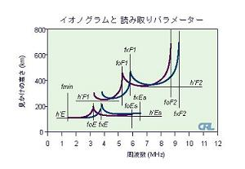
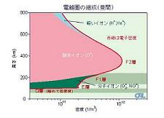

Ionosphere
Ionospheric Space Weather
Explanations in Japanese and this picture with explanations in English:
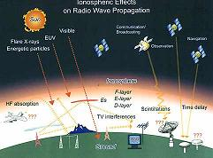

Effects on Radio Propagation
Explanations in Japanese and this picture with explanations in Japanese:
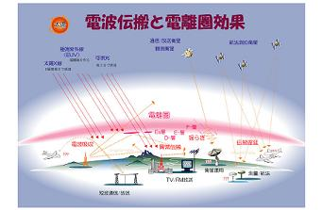

Formation of Ionosphere
Ionospheric Variations
Ionogram
Observations and techniques
Explanations in Japanese and this picture with explanations in Japanese:
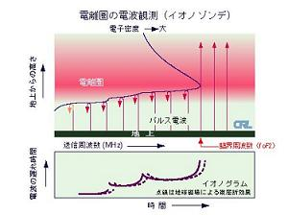

Interpretation of Ionograms
How to read the data
Research
Ionospheric Observation using GPS
Leonide meteor shower
Overseas stations
Topside electron density
Link
World Data Center for Ionosphere
Antarctic exploration
Links

