

Deliverable Identification Sheet

Contract No.: | EDC- 11150 DIAS 28665
Project full title | State of the art report

Deliverable number/name | D-2.1
Security (distribution level) | Restricted
Contractual date of delivery | T9 = November 2004
Actual date of delivery | 17 January 2005
Type | Report
Status & version | Final
Number of pages | 36
Deliverable contributing to WP | WP 2
Author(s) | Anna Belehaki (NOA)  Christer Juren (IRF)  Maria Winnebäck (IRF)  Iwona Stanislawska (SRC-WARSAW)
WP / Task responsible | IRF
Other contributors | NOA, UOA, CCLRC, INGV, IRF, IAP, SRC, BLS

Abstract (for dissemination)
In this report we present a study and analysis of the operation of systems developed worldwide, providing information for the state of the upper atmosphere. A detailed list of added value products and services delivered in the commercial, industrial and scientific community is also presented.

Table of contents

Introduction 3
1. Overview of the worldwide activities 4
1.1 World Data Centers, WDC 4
1.2 Activities outside Europe 4
1.3 Current situation in Europe 9
1.4 List of organizations 10
2. Available data, products and services outside Europe 11
2.1 Data, ionograms and visualization tools 11
2.1.1 Summary 16
2.2 Added-value products 17
2.2.1 Ionospheric maps 17
2.2.2 Ionospheric predictions 19
2.2.3 Reports, Warnings and Alerts 23
2.2.4 Consultancy and support 24
2.2.5 Summary 24
2.3 Distribution channels 25
3. Available data, products and services in Europe 26
3.1 Raw data 26
3.2 Added-value products 26
Conclusion 29
Appendix A1: Types of Ionospheric stations 31
Appendix A2: Formats of ionospheric raw data 33
Appendix A3: Ionospheric models 34

Introduction

The purpose of this report is to present an analysis of the operation of systems developed worldwide, to provide data products and services for the upper atmosphere, and to record the added value products that are delivered in the commercial, industrial and scientific community. The information was basically collected through contacts with representatives from academic institutions, science councils, research and development centres and private companies in many countries worldwide, as well as through Internet investigation.
First an overview of the activities worldwide concerning operational servers established to deliver digital information for the state of the upper atmosphere is presented. World Data Centers (WDC) come first in this investigation, as the most widely known networks of data exchange and distribution, although the emphasis is given on historical data. Other systems providing digital information for the upper atmosphere have been identified in USA and Australia. However some reference to relevant activities in China, in South Africa and in Japan are also included in this subsection. The current situation in Europe is reported next. Two European institutes provide services for the ionosphere. These two organizations, participating in DIAS consortium, will greatly contribute based on their pre-existing experience, for the development of reliable products and services.
Once the worldwide activities are identified and recorded, the next phase of this investigation concerns the specification of added value products and services released worldwide. A detailed description of the available information, both outside and inside Europe is given. This report is mainly used to specify the added value products that will be developed in WP3 “Content Generation” and for the DIAS prototype development in WP4. Based on the analysis made for the compilation of this “State of the Art report”, the basic products and services that will be provided by DIAS have been identified and compared with related products available from other organizations. The conclusion from this comparison is that DIAS has the potential to cover the needs of the market for various types of products and services that are not available currently by any organization in the world.

1. Overview of the worldwide activities

1.1 World Data Centers, WDC

The World Data Centre (WDC) was established at the International Geophysical Year (IGY) of 1957. The special committee for the IGY set up by the International Council of Scientific Unions (ICSU) to serve the IGY, and developed data management plans for each IGY scientific discipline. WDC system secures access to solar, geophysical and related environmental data and serves the whole scientific community by assembling, scrutinizing, organizing and disseminating data and information.
World Data Centers operate for the benefit of the international scientific community. However WDC’s do not provide added value products and services for operational applications since their aim is to serve the scientific community. Information about WDCs or data that they maintain can be obtained through the Internet website: (http://www.ngdc.noaa.gov/wdc/wdcmain.html).
DIAS related information is collected only by some WDC in USA, Australia, Japan and UK:

WDC for STP (Ionospheric Data Archived) at National Geophysical Data Center, NGDC, Boulder, http://www.ngdc.noaa.gov/stp/IONO/ionohome.html
WDC for Solar-Terrestrial Science (STS) in Sydney operated by IPS, http://www.ips.au.gov.
WDC-C2 for Ionosphere in Japan, http://wdc-c2.nict.go.jp/index_eng.html
WDC for Solar Terrestrial Physics in Chilton operated by RAL, http://www.wdc.rl.ac.uk/

1.2 Activities outside Europe

USA

National Oceanic and Atmospheric Administration (NOAA)

NOAA operates two servers SPIRD and SEC and also provides real-time ionograms from the three dynasondes operated in Baker Lake, Lycksele and Tromso (see Appendix 1) http://www.ngdc.noaa.gov/stp/IONO/Dynasonde/BL_TR_LY.htm

Space Physics Interactive Data Resources (SPIDR)
http://spidr.ngdc.noaa.gov/spidr

The Space Physics Interactive Data Resource (SPIDR) is designed to allow a solar terrestrial physics customer to intelligently access and manage historical space physics data for integration with environment models and space weather forecasts. SPIDR is a distributed network of synchronous databases and 100% Java middle-ware servers accessed via the World Wide Web. By enabling easy data mirroring and eliminating the network bottlenecks associated with transcontinental links, the distributed system architecture is a key factor for low latency in multimedia data visualization and fast data delivery.
The key concept in the SPIDR architecture consists of the data basket (a collection of different space weather parameters selected from different databases for the same time interval) and the “event” system. The data basket allows the user to manipulate and deliver the data in various standard formats for easy integration into existing tools. The "event" system is designed to allow the user to specify desired spatial, temporal, and parameter conditions in fuzzy linguistic and/or numeric terms and then to mine the archives and receive a ranked list of space weather events best matching the desired conditions in the historical archive.
Once an event is discovered or identified, the client can request dynamical temporal and spatial visualization using a set of communicating Java applets, browse the archive of Sun and Earth satellite images and request delivery of the data formatted for inclusion in model runs.
Each SPIDR node has a database management interface, which allows data updates performed either by a local user or by another SPIDR server from the Net. The servers communicate with each other for scheduled mirroring of the data and software. Actually mirror sites are in Boulder (http://spidr.ngdc.noaa.gov/spidr/), Moscow (http://clust1.wdcb.ru/spidr/), Kamchatka (http://spidr.kamchatka.ru/spidr/index.jsp), Nagoya (http://gedas22.stelab.nagoya-u.ac.jp/spidr/), Sydney (http://spidr2.ips.gov.au/spidr/).
SPIDR services are public and open to all Internet users.

Space Environment Center (SEC)
http://www.sec.noaa.gov/
The Space Environment Centre (SEC) provides real-time monitoring and forecasting of solar and geophysical events, conducts research in solar-terrestrial physics, and develops techniques for forecasting solar and geophysical disturbances. SEC's Space Weather Operations Centre is jointly operated by NOAA and the U.S. Air Force and is the national and world warning centre for disturbances that can affect people and equipment working in the space environment.
Concerning Ionospheric Nowcasting and Forecasting, SEC provides with the following services:
List of ionospheric parameters
Predictions of ionospheric disturbances

UMass Lowell Center for Atmospheric Research (UMLCAR)
http://ulcar.uml.edu/index.html
The Center was founded with the goal of conducting experimental and analytical research in the atmospheric and space sciences, to provide research opportunities for graduate and undergraduate students and to demonstrate how research and development contribute to solving real world problems.
The Digisondes mainly used in DIAS have been developed and produced here (see Appendix 1).
Recently, a database system (DIDB) has been developed in Lowell, which posses sounding files from Lowell Digisondes for the recent years. Users with authorized access can retrieve manually the stored ionograms and re-scale them. Users can download ionospheric parameters as well as ionograms and electron density profiles.

Northwest Research Associates (NWRA)
http://www.nwra-az.com/nwra_spawx.html
Northwest Research Associates, Inc., (NWRA) is a small scientific research group with a primary focus in the geophysical sciences that includes, but is not limited to: oceanography, sea-ice mechanics, and atmospheric, ionospheric, and solar physics.
NWRA is a recognized world leader in ionospheric modeling, particularly in the critical field of ionospheric scintillation. NWRA have developed and maintain the only global model for ionospheric scintillation, the WBMOD model. NWRA can also assess other potential ionospheric impacts on a system, such as Faraday rotation or time delay, using other ionospheric and propagation models. Their customers include government agencies, (including the USAF Weather Agency, the USAF Space and Missile Systems Organization, and the NOAA Space Environment Center), as well as commercial organizations (Boeing, Lockheed Martin, and Ball Aerospace).
NWRA can provide general assistance with space-weather problems. They monitor the state of the near-earth space environment using data collected by the NOAA Space Environment Center (SEC).

Fusion Numerics
http://www.fusionnumerics.com/
Fusion Numerics is a software engineering firm developing custom predictive platforms for its clients. Fusion Numerics applies predictive modeling techniques from weather forecasting to complex real-world problems. They are using GPS-TEC data to develop their services, which are restricted to their clients.
Fusion Numerics has been in business as a Limited Liability Company since April 2000 and was incorporated in 2003.

Fusion Numerics’ Ionospheric Portal
http://63.231.68.133/ionosphere/DesktopDefault.aspx
This site serves as the gateway to the global numerical ionospheric forecasting system, IonoNumerics, and provides a place for users to monitor and analyze the output, access web services and get more information about the system. System development is sponsored by the Air Force Research Laboratory and began in the spring of 2002.
Comparison between Dynasonde data and IonoNumerics models can be found on:
http://www.ngdc.noaa.gov/stp/IONO/Dynasonde/IonoNumerics.htm
The main objective of this project is to design, develop and deploy an operational system for nowcasting and forecasting electron densities in the Earth's ionosphere. Such a system is of interest to military and civilian operations dependent on GPS navigation as well as other related industries. Similar to current numerical weather prediction models, the system is composed of two parts: a first principles physics-based model of the ionosphere and a module for assimilating real-time observations to continually adjust ionospheric model calculations.

Australia

IPS, Ionospheric Prediction Service
http://www.ips.gov.au

IPS acts as the Australian Space Weather Agency, providing the Australian national radio propagation and space weather services. Systems and technologies affected by space weather, and supported by IPS, include:

HF radio systems, such as communications and surveillance systems.Support is also provided for international and domestic research into the space environment. IPS operates an extensive network of monitoring stations and observatories within the Australasian region and in Antarctica to gather information on the space environment in support of their customers' operations. IPS exchanges this information with similar organizations worldwide.

IPS operates the World Data Centre (WDC) for Solar-Terrestrial Science (STS) in Sydney. The Centre provides Solar and Ionosonde data as well as Space Physics Interactive Data Resources (SPIDR).
Information from the IPS website is open to the public.

Japan
National Institute of Information and Communications Technology – NICT
Provides Space Environment Information Service (http://hirweb.nict.go.jp/index.html) - among space weather information also regular observation of ionosphere and space environment information services and recorded daily
(http://www.nict.go.jp/overview/about/operation_e.html)
HF Radio Telecommunication Index created by Hiraiso and SWF probability is a part of Japanese ISES information (http://crlhir.nict.go.jp/tserdin/forecast/ratef.html).

South Africa

Hermann Ohlthaver Institute for Aeronomy
http://phlinux.ru.ac.za/hoia/
The Hermann Ohlthaver Institute for Aeronomy (HOIA) was established in December 1983.
HOIA falls under the management of the Hermanus Magnetic Observatory, a national facility of the National Research Foundation (NRF).
In earlier years research was fairly broadly based, involving the ionosphere over Antarctica, Gough Island and Grahamstown, as well as local Middle Atmosphere studies and theoretical work. With the rationalization of the Antarctic program away from HOIA, the emphasis has moved towards more local and applied research that lies more firmly in the Ionospheric communications field. Current research explores the use of artificial Neural Networks as an aid to Ionospheric prediction, the use of meteor trains to establish the dynamics of the lower ionosphere, and the expansion of the measurement capabilities of the DPS Ionosondes.
HOIA Provides foF2 and foE Prediction Service for South African Region and foF2 Forecast Service for Grahamstown. The South African Ionospheric Center operated by HOIA (http://ionosond.ru.ac.za/) provides available data and ionograms from 3 stations in South Africa. To access the data permission is required.

China
Ionospheric sounding in China has a long history and has a well spread network, which is still in routine operation, providing a good background to do ionospheric long-term prediction and short-term forecasting. Ionospheric sounding in China started in the early 1940s. 11 ionosonde stations are still in operation on the Chinese mainland. The data at integer UT hours are sent to a forecasting center in Beijing twice a day over the Internet.
A method of predicting the ionospheric F2 layer in the Asia and Oceania Region (AOR Method) was adopted as a regional ionospheric long-term prediction method in China and its surrounding area. This was then combined with the International Reference Ionosphere and became the Reference Ionosphere in China (CRI).

1.3 Current situation in Europe
The collection and distribution of the ionospheric data and products in Europe for scientific and commercial use is currently possible mainly through the following Research Centers: Rutherford Appleton Laboratory in United Kingdom (http://www.wdc.rl.ac.uk/cgi-bin/digisondes/cost_database.pl). RAL through the Space Weather Web provides plots of ionospheric parameters in real-time and archive format at selected locations, and ionospheric and trans-ionospheric maps for nowcasting and forecasting purposes.
Space Research Centre in Poland (RWC Warsaw http://www.cbk.waw.pl/rwc). SRC provides forecasts of the foF2 parameter at selected locations and regional ionospheric maps.
Both research centers belong to DIAS consortium and this is considered to be a big advantage for the projects because of the pre-existing know-how on the development of reliable added-value products and services.

1.4 List of organizations

Organization | Services for operational applications | Services for research | World area covered
WDC | No | Yes | Worldwide
SPIDR | Yes | Yes | Worldwide
UMLCAR (DIDB) | No | Yes (DIDB database) | Worldwide
SEC | Yes | Yes | Worldwide
NWRA | Yes | Yes | Worldwide
Fusion Numerics | Yes | No | Worldwide
IPS | Yes | Yes | Worldwide
NICT | No | Yes | Japan
HOIA | No | Yes | South Africa
Beijing Forecasting Center | No | Yes | China
RAL | Yes | Yes | Europe
SRC-Warsaw | Yes | Yes | Worldwide

The list presented above indicates that six digital servers (SPIRD, SEC, NWRA, IPS, RAL and SRC-Warsaw) operate worldwide to offer products and services for nowcasting and forecasting the ionospheric part of the upper atmosphere. All these servers are using raw data obtained by digital ionospheric stations, therefore their products and services can be directly compared to those aimed to be released by DIAS. Fusion Numerics provides nowcasting and forecasting electron densities in the Earth’s ionosphere, based on TEC data from GPS. The access is restricted and the main user of this service is the defense sector.

2. Available data, products and services outside Europe

2.1 Data, ionograms and visualization tools

IPS Radio and Space Services (http://www.ips.gov.au/)
- Ionograms: IPS provides an interactive tool, Ionogram Viewer, to manually scale the following 11 parameters from the ionograms in the Australian region (17 stations): fmin, foE, hE, foEs, fbEs, hEs, foF1, hf, foF2, fxI, hF2. Within Australasia region IPS provides synthetic equivalent oblique ionogram from the vertical ionogram. There are options of distances, from 300 km to 3500 km, to choose from for the derivation of the equivalent ionogram. IPS also provides printable ionogram images (gif-format).
- Archive data: IPS provides ionospheric data obtained from 22 ionospheric stations operating in the Australian region through the World Data Centre (WDC) for Solar-Terrestrial Science (STS).
- The access is open with no registration requirement.
- The user can use the Data Display Tools to access the ionospheric data available in hourly resolution.
- The Ionospheric Data Display Tool is an interactive tool that accepts user’s selection upon Station, Parameter, Year, Month and Day.
- The following ionospheric characteristics are provided
foF2, M(3000)F2, h’F2, foF1, h’F, foE, h’E, foEs, fbEs, h’Es, fmin, fxl.
- The user can choose either the Display Data option to get the Ion data and Line Graph in the following format presented below:

or the Download option to download the whole year data.

Another interactive tool is the Medians that accepts user input for Median (foF2 or M(3000)F2), Station(s) and Date and displays Medians and Line Graph. Users are also given the choice to download the whole data file of the specified Median and Station.

Space Physics Interactive Data Resource (SPIDR): http://spidr.ngdc.noaa.gov/spidr
The Space Physics Interactive Data Resource (SPIDR) is designed to allow researchers to access and manage historical space physics data for integration with environment models and space weather forecasts. SPIDR is a distributed network of synchronous databases and 100% Java middle-ware servers accessed via the World Wide Web.
- On login as Guest the visitor can view but not download data from SPIDR. To avoid the restrictions the visitor has to register his own account.
- The registration is free, and the requested personal data are used only for SPIDR usage statistics.

Concerning the ionospheric data,

- Ionospheric data at SPIDR in USA are available from November 1904 to November 2004 depending on the station.
- The SPIDR database covers 226 ionospheric stations, distributed around the world.
- The native time step is 15 min or 1 hr depending on the provider station. However, the nearest native time step data is used for interpolation or averaging and data with fixed time steps like 30 min or 3 hours (from 1 min to 1 year), can be available for data export or plotting.

The users can interactively choose
- station from map or list.
- one or all of these groups of ionospheric parameters:
E layer: foE, h'E
Es layer: foEs, fbEs, h'Es
F1 layer: foF1, h'F1
F2 layer: foF2, h'F2, hmF2, hc
- Or one or all of the following additional parameters: h’F, hpF2, fxI, M(3000)F2, MUF(3000)F2, fmin, fminF, fminE, fMUF(3000), h’MUF(3000)hmF1, ITEC, B0, B1, D1, Type Es, fmI, hmE (one or all).

Next, the users can request:
- Download data in ASCII, Matlab, XML, or IIWG format (see Appendix II).
- Time plots and line graphs from all stations providing data to SPIDR.
SPIDR can plot time series with static GIF images or with dynamic Java applet.
There is also the possibility to zoom in and out in the graph (Java applet).

Space Environment Center (SEC) (http://www.sec.noaa.gov)
SEC provides a wide variety of near-real-time and recent Space Weather data online through its Web and FTP sites. In particularly, concerning the ionospheric observations:
- SEC currently receives data from 52 stations. New stations are added as resources permit.
- Data is received at SEC in two formats: IUWDS and SAO and provides Ionospheric Data Lists as ascii files with one station per file. The time step is 15 min or 1 hr depending on the station-provider.
- SEC provides both Daily and Monthly Ionospheric Data lists for each station.

In summary, the available ionospheric data are described bellow:

List  Ionospheric parameters - foF2, hmF2, M(D), D, h'F, yF2, fMUF, h,' fxI, foF1, foE, hmE, foEs, fbEs, ITEC | Updates  hourly | Latest  (near real-time)  latest | Older  3 months

ISDJ (Japan)
Ionospheric Sounding Data in Japan (http://wdc-c2.nict.go.jp/ISDJ/index-E.html) provides ionograms and parameters from 4 stations in Japan.
- Ionogram resolution: 15 minutes
- Data resolution: 1 hour.
- Ionograms and parameters value are available 30 days back in time.

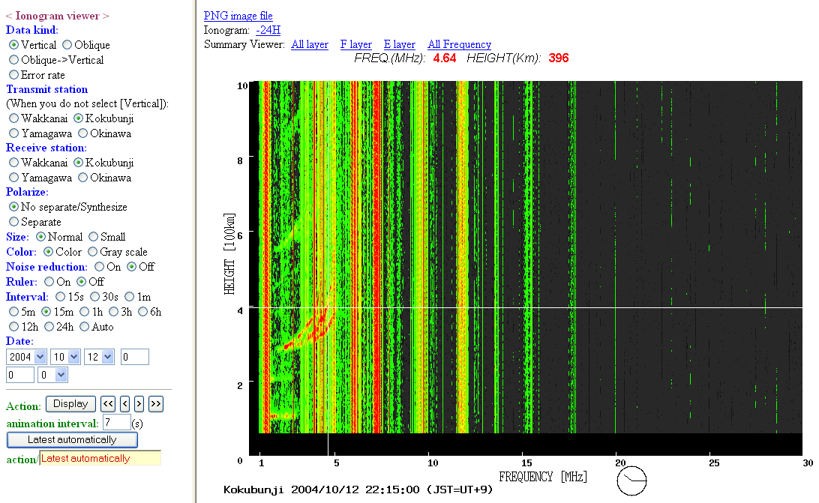

Additional products
- Latest data, vertical, oblique, oblique -> vertical, in color or monochrome from 4 stations in Japan.
- Summary of all layers, F layer, E layer and of all frequencies.
- Mpeg movie for the latest 48 hours.
- Search past 30 days and display as mpeg movie (1 day unit).
- By moving the mouse over the ionogram it is possible to see the frequency and height for the special point.
- Factor values provided from Ionograms, indicated in HTML format or booklet format (graphic file).

2.1.1 Summary
The type of raw data available from different world organizations are summarized in the following table:

 | Ionograms | Parameters |  | Real time data | Historical data | Area covered
 | Ionograms | ASCII | Graphical Output | Real time data | Historical data | Area covered
IPS | Yes | Yes | Yes | Yes | Yes | Australia
SPIDR | No | Yes | Yes | No | Yes | Worldwide
SEC | No | Yes | No | Yes | No | Worldwide
ISDJ | Yes | Yes | Yes | Yes | Yes | Japan

2.2 Added-value products

2.2.1 Ionospheric maps

IPS (Australia)
http://www.ips.gov.au/Main.php

T-Index Map and foF2 Map
The real-time observations (autoscaled values) are converted to T-indices or equivalent sunspot numbers. This normalizes the incoming data from different locations. A map, using the Kriging technique is then constructed, extrapolating outside the data region by a reasonable amount. To give an impression of how much the map based on real-time measurements corresponds to the monthly median map, a difference map is constructed. This is diagnostic.
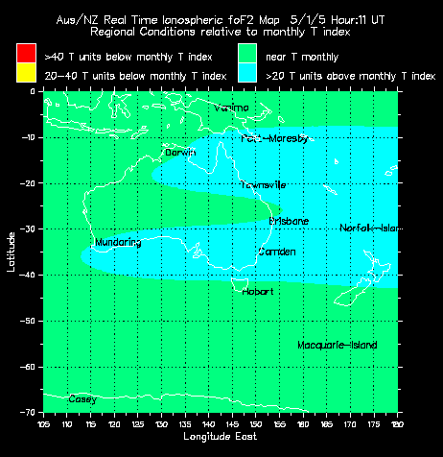

Having produced the T-index map for a region, a new real-time map of foF2 is made by applying the T-index map to the ionospheric model. That produces the real-time ionospheric map. An example of the map’s layout format is given below.

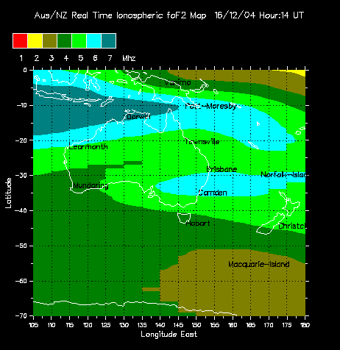

Following this procedure, a near-real time foF2 map in hourly resolution is produced by IPS for the following world areas: Australasia, Asia, Europe, N. America, N. Atlantic. Ionosonde data from each of these world regions are used for the construction of the corresponding map. For the European region, real-time autoscaled values provided by Athens, Rome and Chilton Digisondes are used.

2.2.2 Ionospheric predictions

IPS (Australia)

HAP Charts
The HAP chart is a guide to frequency selection for HF communications between mobiles and a specified base station, in this case Sydney. The recommended frequency for communications with the base at a given hour is read off from the point in the map corresponding to the mobile's location. The predictions are made from real time data, for different world areas: Australasia, Asia, Europe, N. America, N. Atlantic. For Europe, HAP charts are constructed based on real-time data provided by Athens, Rome and Chilton Digisondes.
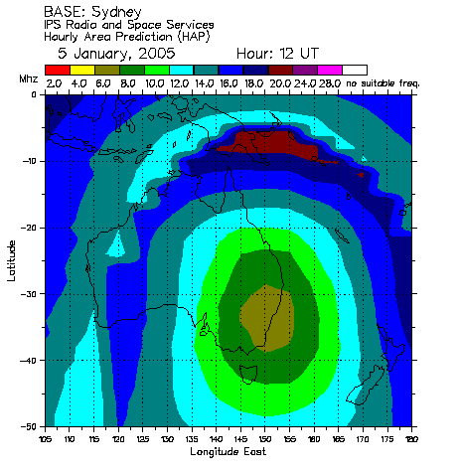

HF predictions
The following HF predictions are also supplied by IPS:

Air Route chart: It shows the recommended frequencies for contacting a base point as an aircraft approaches.
- LAMP Charts: A LAMP (Local Area Mobile Prediction) chart shows frequencies which can be used for communications in a small area (located within 1000km or 1000nm from the base station). The LAMP charts are derived from IPS real-time data for recent days. The charts are based on observed ionospheric conditions for each hour of the day.
- Point-to-point HF Communication prediction, short or long path.
- Predictions for planning purposes

SEC (USA)
The Space Environment Service (SEC) provides predictions of the foF2 disturbance using the Ionospheric Correction Model – STORM, which runs online (http://www.sec.noaa.gov/Data/alldata.html).
The STORM model provides an estimate of the expected change in the ionosphere during periods of increased geomagnetic activity. The model estimates the departure from normal of the F-region critical frequency (foF2) every hour of the day for the current and previous day. Values are given in six separate geomagnetic latitude bands, 20° wide, from 20° geomagnetic latitude to the North and South magnetic poles. Storm-time corrections within 20° of the magnetic equator are not made. The corrections are given in terms of a scaling factor, which can be used to adjust the climatological mean. As the ionosphere departs further from normal the color of the trace changes from green, to yellow, to red, where green represents changes within 10% of normal, and red indicates departures in excess of 25%.
The STORM model was developed from ionospheric observations during many storms that were analyzed as a function of season and latitude. Within each season and latitude sector, the magnitude of the ionospheric response was determined as a function of an index parameterizing the magnitude of the storm. The storm magnitude index depends on the previous 33 hours of a_{p}, weighted by an appropriate filter. The optimum length and shape of the filter was obtained by a singular value decomposition method. The real-time model uses the hourly values of the 3-hour running a_{p}, provided by the USAF Hourly Magnetometer Analysis Reports. The blue line in the lower boxes shows the hourly value of the integrated a_{p}, which is the index used to drive the model.

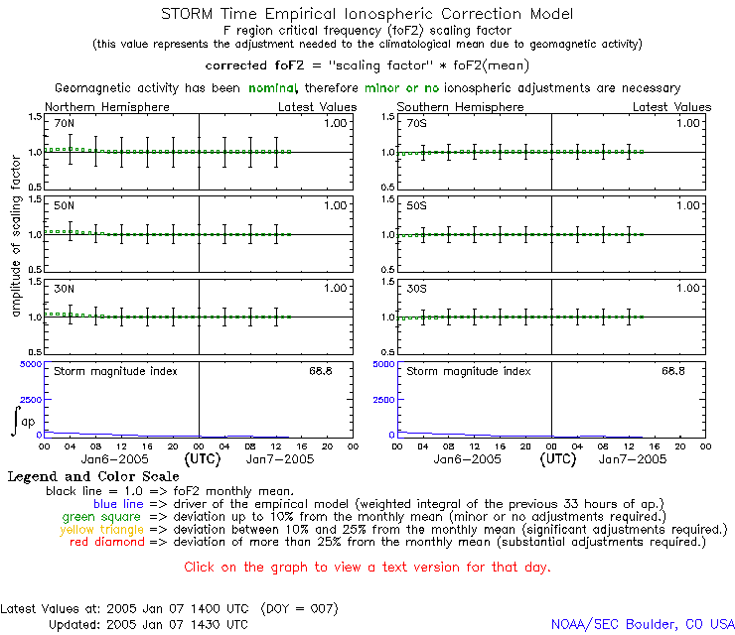

NWRA (USA)
They provide the Effective Sunspot Number (SSNe) derived from ionospheric measurements at a single station. The effective sunspot number (SSNe) index is defined as that SSN which will return a zero average-error between foF2 values generated from a model (URSI-88) to which the SSNe is input, and a set of foF2 observations.

Effective Sunspot-Number Indices
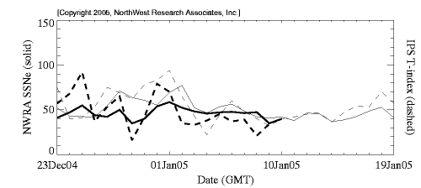
This plot illustrates the differences between the "real" sunspot number (SSN), and a sunspot number derived from fitting an ionospheric model to ionospheric measurements. All of these indices are used as inputs to models of the ionosphere for use in communications-performance predictions.
The SSNe is equivalent to the IPS T-index. The difference between all these indices is due to the fact that they are based on a different model. SSNe is based on URSI-88, T-index is based on IRI (see Appendix 3).

2.2.3 Reports, Warnings and Alerts

IPS (Australia) provides Reports and Alerts for following subjects:
- HF Propagation Conditions
- Ionospheric Conditions in Australasia, North America and Europe

An example of an HF Radio Communication Warning, issued only for the Australian and New Zealand region is given below:

SUBJ: IPS HF RADIO COMMUNICATIONS WARNING 04/56
ISSUED AT 16/2234Z DECEMBER 2004
BY THE AUSTRALIAN SPACE FORECAST CENTRE.

MODARETLY DEGRADED HF PROPAGATION CONDITIONS EXPECTED
FROM 17-18 DECEMBER 2004 SOUTHERN AUS/NZ REGION ONLY,
IF COMMS DIFFICULTIES EXPERIENCED TRY A LOWER FREQUENCY BAND
_____________________________________________________________

SOLAR ACTIVITY FORECAST HF COMMS FADEOUTS
17 Dec: very low None expected
18 Dec: very low None expected

HF COMMUNICATIONS FORECAST (AUSTRALIAN/NEW ZEALAND REGION)
FREQUENCY BANDS
T-index MUFs 2 4 6 8 12 16 22 26
_____________________________________________________________
17 Dec -5 -15%/normal 2 4 6 8 12 12 16 22
18 Dec -5 -15%/normal 2 4 6 8 12 12 16 22

Reports and alerts are issues to subscribed users who become members of the IPS mailing lists. The following types of reports are issued:
- Daily HF Propagation Report. A 1-day summary and 3-day forecast of HF propagation and ionospheric conditions in the Australian region.
- Automated Daily European HF Propagation Report. A 1-day summary and forecast ionospheric conditions for the European region based on ionospheric foF2 real-time data supplied by Rome, Chilton, and Athens Digisondes. A real-time European T Index is produced from these data as well. This is combined with both estimated and forecast A Index information from the Space Environment Centre in Boulder USA. The two of these together make up an automated summary and forecast of European regional HF conditions. The report is issued at 6:30UT daily.
- Weekly HF Propagation Report. A 1-week summary and forecast of HF propagation and ionospheric conditions. Also, a 1-month outlook for disturbed HF propagation conditions for the Australian region.
- Monthly report of the IPS Observed and Predicted T Indices.

2.2.4 Consultancy and support

NWRA
The Earth's ionosphere can cause a wide range of undesirable effects on radio signals passing through it, including refraction, group delay, Doppler shift and spread, polarization rotation, and scintillation. NWRA has both the models and expertise to help in planning systems and operations to avoid or ameliorate these effects and to aide in assessing problems as they are encountered.

IPS
IPS provides specialist-consulting services to support the design of new HF radio systems and networks or the re-configuration of existing ones. These services are closely tailored to customer needs. Their range of information and support includes:
- Area of coverage charts and propagation analysis across HF networks
- Frequency Management Software for integration into users’ systems
- Ionogram auto-scaled software
- HF Antenna modeling and footprints

2.2.5 Summary
A list of added-value products available is given in the following Table.

 | IPS | NWRA | SEC
Nowcasting products | foF2 maps | None | None
Forecasting products | T-index  HAP charts  HF predictions | Effective sunspot number (SSNe) | foF2 values
Alerts | HF communication warning | None | None
Reports | HF propagation report  Observed and Predicted T-index | None | None
Consultancy | Yes | Yes | No
Geographic area covered | Europe: foF2 maps, T-index, HAP charts, HF communication warning  Australia, New Zealand: all products | The SSNe index is calculated at a single station location, from which data are available to NWRA including some European stations | Worldwide coverage

2.3 Distribution channels

Those organizations providing alerts, warnings, forecasts, plots, data lists and maps are using as main distribution channel the web browser (http, ftp). Emailing lists as these established in IPS are serviced via e-mail. Under special contracts with customers, some of the information may be delivered via alternative channels such as SMS, FAX and telephone.

3. Available data, products and services in Europe

3.1 Raw data
Rutherford Appleton Laboratory (UK)

The Ionospheric database developed at Rutherford Appleton Laboratory (http://www.wdc.rl.ac.uk/cgi-bin/digisondes/cost_database.pl) provides real-time and historical data from several European observatories. The database provides all possible ionospheric parameters derived from the ionograms, and electron density profile data in plot and ASCII format.

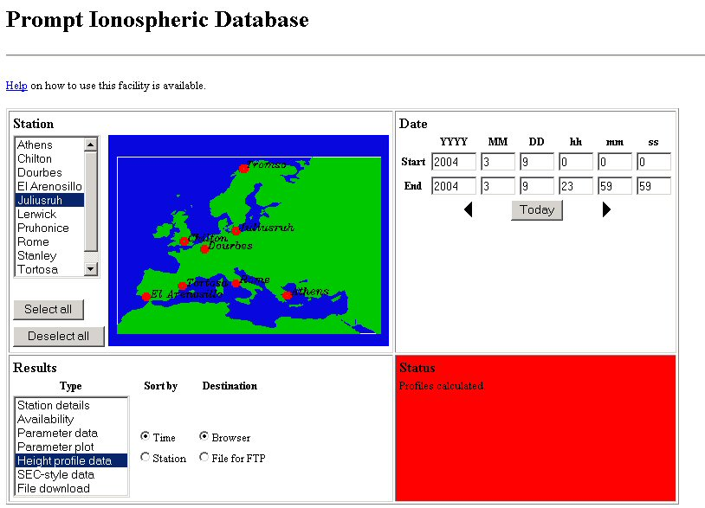

Space Research Center (Poland)

The Regional Warning Center in Warsaw holds an archive of ionospheric parameters for the last two months, from several stations distributed worldwide, which can be downloaded in IWG format (http://www.cbk.waw.pl/rwc1/en/index.html).

3.2 Added-value products
Rutherford Appleton Laboratory (UK)

Ionospheric forecasts are provided up to 24 hours ahead, using an autoregressive procedure developed jointly by the Radio Communications Research Unit and the Geophysical Institute of the Bulgarian Academy of Science.
The latest European forecast maps of foF2 and MUF(3000)F2 are available.

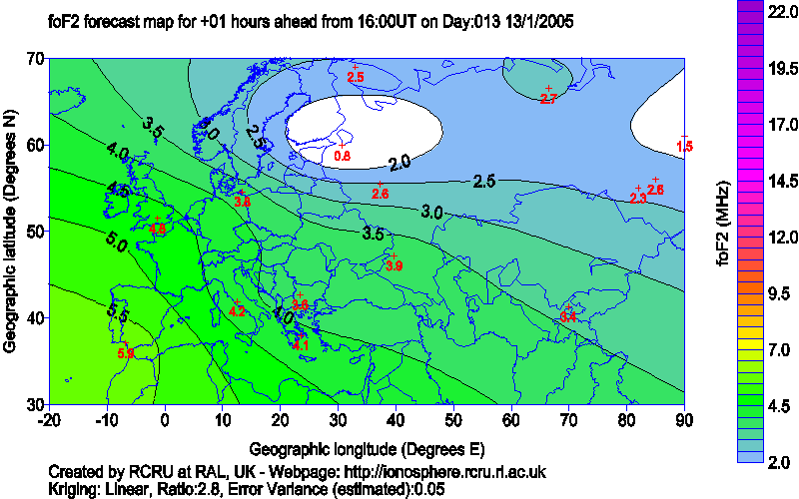

An archive of these maps is also available from RAL Space Weather Web site.
Using the short term ionospheric forecasting method, RAL provides forecasts of foF2 and M(3000)F2 parameters for selected locations in Europe (http://ionosphere.rcru.rl.ac.uk/).

Space Research Center (Poland)

The Regional Warning Center of the SRC in Poland provides up to 24 hours regional maps of the ionosphere for Europe, Australia and Japan (http://www.cbk.waw.pl/rwc1/en/index.html). Forecasting values are calculated with the autoregression method.

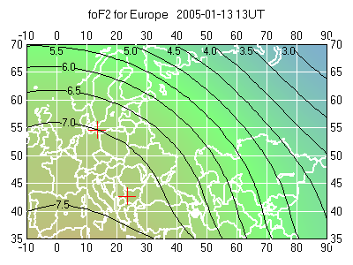
The Regional Warning Center in Warsaw provides forecasts of the foF2 parameter at selected stations (http://www.cbk.waw.pl/rwc1/en/index.html), for the next 24 hours, using the autocorrelation technique.

Conclusion

The State of the Art report, released in the frames of WP2 of the DIAS project, for the investigation of the worldwide activities similar to DIAS, identified six organizations with public access, operating servers for acquisition, elaboration, evaluation, dissemination and archiving of information for the upper atmosphere: IPS (Australia), NWRA (USA), SEC (USA), SPIDR (USA), RAL (UK), SRC (Poland).
In particular, NWRA provides a very specific service concerning the real-time availability of the effective sunspot number at specific locations where ionospheric stations operate. The server operated by SEC has as basic objective the development of products and services for the nowcasting and forecasting of space weather. Ionospheric predictions are only a small part of these services and are limited to the prediction of foF2 disturbances for six geomagnetic latitude bands, at middle latitudes. The server operated by NOAA (SPIDR) is designed to serve mainly the research community. Therefore, the emphasis is given on the accessibility and on the management of historical data with the development of fast delivery and visualization tools.
On the other hand, IPS provides Space Weather Services mainly for Australia and New Zealand and merely for other regions of the world, including Europe. An important part is dedicated to HF services and products while considerable information is delivered for the state of the upper atmosphere. In this aspect, IPS could be compared more straightforward with DIAS, although DIAS is dedicated to serve exclusively the needs for information on the ionospheric part of the upper atmosphere. It is also important to note that IPS services for Europe are based on information obtained from DIAS digisondes.
Concerning the European region, RAL and SRC operate ionospheric servers. The two organizations posses important know-how on the development of added value products and services for the upper atmosphere. These two organizations, participating in DIAS consortium, will greatly contribute based on their pre-existing experience, for the development of reliable products and services. The methods already used by RAL and SRC for mapping and forecasting, and their limitations, have been already discussed among the consortium members. Moreover, in the frames of the European Action COST 271 “ Effects of the upper atmosphere on terrestrial and Earth-space communications”, several models were developed and tested for its performance. Most of the European institutes that worked for the development of these models in COST271 participate in DIAS consortium. Therefore, based on this pre-existing experience, and on the analysis made for the compilation of this “State of the Art report”, specific methods for accurate prediction and realistic mapping of the upper atmosphere have been suggested. The basic products and services that will be provided by DIAS concern: real-time and historical data and ionograms, plots of important ionospheric parameters (foF2, fmin, M(3000)F2) and maps of foF2, M(3000)F2, MUF and electron density. The detailed determination of all products and services that will be finally released, will be decided taking also into account the actual needs of the users, that will be summarized on the “Users needs assessment report”.

Comparative Table of the basic products and services that will be provided by DIAS and those already available from other organizations for the state of the upper atmosphere over Europe
 | DIAS | IPS | NWRA | SEC | SPIDR | RAL | SRC
Real-time ionograms | Yes | No | No | No | No | No | No
Historical ionograms | Yes | No | No | No | No | No | No
Plots of foF2 | Yes | No | No | No | Yes | Yes | No
Plots of fmin | Yes | No | No | No | Yes | Yes | No
Map of foF2 (nowcasting) | Yes | Yes¹ | No | No | No | Yes | Yes
Map of M(3000)F2 (nowcasting) | Yes | No | No | No | No | Yes | No
Map of foF2 (forecasts) | Yes | No | No | No | No | Yes | Yes
Map of M(3000)F2 (forecasts) | Yes | No | No | No | No | Yes | No
MUF maps (nowcasting) | Yes | Yes² | No | No | No | No | No
MUF maps (forecasts) | Yes | Yes² | No | No | No | No | No
Maps of electron density (nowcasting) | Yes | No | No | No | No | No | No
Maps of electron density (forecasting) | Yes | No | No | No | No | No | No
Effective Sunspot Number | Yes | Yes | Yes | No | No | No | No
Alerts of ionospheric disturbances | Yes | Yes | No | No | No | No | No
¹ Almost real-time (one hour delay)
² IPS provides HAP charts for Europe

From this comparative table is obvious that DIAS has the potential to cover the needs of the market for various types of products and services that are not available currently by any organization in the world.

Appendix A1: Types of Ionospheric stations

Modern digital ionospheric stations are used worldwide as a tool to remotely sense the ionospheric part of the upper atmosphere and identify its structure and properties. Most digital ionospheric stations have the capability of automatically scaling and transmitting in real-time all important parameters characterising the state of the ionosphere and the propagation of radio waves. Nevertheless there are considerable differences on the built-in software for the post-processing of the observations, which is of crucial importance for the reliable scaling of the ionograms in real-time and the identification of the ionospheric structure.
From our investigation, the following types of ionospheric sounder operate in different organizations worldwide:
CADI http://cadiweb.physics.uwo.ca/
IPS-71 http://www.kel.com.au/products/ips71.htm
BIZON http://www.ips.gov.au/IPSHosted/INAG/web-60/bizon.htm
PARUS http://top.izmiran.troitsk.ru/parus/
KOS (System developed by the Polish Academy of Science and operated by Warsaw and Sofia stations)
Digisonde http://ulcar.uml.edu/framesd.htm
Dynasonde http://www.ngdc.noaa.gov/stp/IONO/Dynasonde/

It is well accepted through the scientific community that Digisondes have one of the most reliable software tools (ARTIST) for the automatic scaling of ionograms. The operation of Digisonde stations from the majority of DIAS partners guarantees the reliability of raw data and hence the grater accuracy of the added value products.
Dynasonde is another type of a very advanced digital ionospheric station operated by IRF in Lycksele. To see the main differences of the two types of instruments, one can go in two different directions.
- To look at the data as time series for each frequency and transmitted polarization and store it compressed. (Digisonde)
- To look at the data as detected reflected pulses for each frequency and only keep them as accurate as possible. (Dynasonde)

In the first case one has to store the signal amplitude and phase at each time, which are described as compressed values in range bins, two for each frequency and polarization.
In the second case one store the detected pulse’s amplitude, phase, polarization and the time they were detected. With several antennas and receivers one can easily get angle of arrival.
In the first case one has always to deal with the same amount of data, but in the other the data size is dependent of the received number of pulses.
In the case of transforming the data from a Dynasonde to a Digisonde one has to reconstruct the time series, which seems impossible. But one has to remember that one pulse contains a lot of information and not necessarily less than the time series around it! Anyhow one has to create a lot of dummy data which only fill the most of the rang bins.

Appendix A2: Formats of ionospheric raw data

There are four main formats in use: ‘URSI’, IIWG, ‘ISES’ and SAO. Some more appear as the output from ionosondes in some regional databases for specific purposes.

URSI – URSI Ionospheric Vertical Incidence Parameters is described in the Report UAG23 (URSI Handbook of Ionogram Interpretation and Reduction, November, 1972).
IIWG format used in the past and also still in some WDCs - http://www.wdc.rl.ac.uk/wdcc1/ionosondes/iiwg_format and at ulcar.uml.edu
Ionospheric data (only characteristics) distributed within ISES organization - http://www.ises-spaceweather.org/codebook
SAO format – (recommended by Ionospheric Informatics Working Group (IIWG) of Commission G of URSI)
http://ulcar.uml.edu/digisonde.html

Appendix A3: Ionospheric models

International Reference Ionosphere Model (IRI)
The International Reference Ionosphere (IRI) is an international project sponsored by the Committee on Space Research (COSPAR) and the International Union of Radio Science (URSI). These organizations formed a Working Group in the late sixties to produce an empirical standard model of the ionosphere, based on all available data sources. Several steadily improved editions of the model have been released. For given location, time and date, IRI describes the electron density, electron temperature, ion temperature, and ion composition in the altitude range from about 50 km to about 2000 km; and also the electron content. It provides monthly averages in the non-auroral ionosphere for magnetically quiet conditions. The major data sources are the worldwide network of ionosondes, the powerful incoherent scatter radars (Jicamarca, Arecibo, Millstone Hill, Malvern, St. Santin), the ISIS and Alouette topside sounders, and in situ instruments on several satellites and rockets. IRI is updated yearly during special IRI Workshops (e.g., during COSPAR general assembly). Several extensions are planned, including models for the ion drift, description of the auroral and polar ionosphere, and consideration of magnetic storm effects.
Availability:
Fortran source code from NSSDC's NSSDC's anonymous FTP site; ftp://nssdcftp.gsfc.nasa.gov/models/
Online computation and plotting through IRIweb. http://nssdc.gsfc.nasa.gov/space/model/models/iri.html

NeQuick Model (http://arpl.ictp.trieste.it/nq-programs/demo/helpdemo.htm)
The NeQuick model is a ionospheric electron density model developed by the ARPL-ICTP laboratory and by the IGAM-University of Graz (Austria).
The model has been adopted in the ionospheric specifications for the European Space Agency EGNOS project and more recently by ITU-R Recommendations P. 531-6 as a suitable method for TEC modeling.

CCIR maps
http://nssdc.gsfc.nasa.gov/space/model/ionos/ccir.html
Global maps of foF2 and M(3000)F2 are generated by the Jones-Gallet numerical mapping procedure. In this technique median measured data for each month of reference low and high sunspot numbers are separately mapped in terms of harmonic orthogonal Fourier functions and associated sets of numerical coefficients to give time-of-day, latitude and longitude variations. The numerical coefficients for the separate ionospheric characteristics are determined with different orders of harmonics. The maximum harmonic orders and sets of coefficients adopted (typically 988 coefficients for each month in the case of foF2) should be those for which the rms residuals between the mapped and measured values attain a lower limit.
The Radiocommunication Sector (former CCIR) of the International Telecommunication Union has adopted a set of such maps based on data from some 160 measurement stations collected over the years 1954-58 and 1964.

The IPS T-index
The T index is derived from observed values of maximum ionospheric frequencies and has the same scale as sunspot number. To derive an ionospheric index system such as the T index, it is necessary to make extensive observations of the ionosphere over several solar cycles and to then plot the maximum ionospheric frequency against the sunspot number. From this, it is possible to obtain a relationship between frequency and sunspot number. Then, given some recent observations of maximum ionospheric frequencies, the relationship can be used to derive a value of the equivalent sunspot number - called the T index and it will generally be slightly different to the real sunspot number because of the effects mentioned earlier. That is essentially the way that T indices are derived, although there are complications because it is necessary to repeat the process for each time of the day and for each month of the year.
The T index can be best regarded as an "equivalent sunspot number" - the sunspot number which would best match the observations made by ionosondes. IPS has a large network of ionosondes and can derive the most appropriate T index. This can then be used by IPS customers to get best results for their HF communications.

Simplified Ionospheric Regional Model
The Simplified Ionospheric Regional Model (SIRM) was developed specifically for European ionospheric area. The SIRM calculates the values of the key vertical incidence ionospheric characteristics such as foF2, M(3000)F2, virtual height of the ionospheric F2 layer h’F2, critical frequencies of the ionospheric F1 and E layers foF1 and foE that are used for prediction of operational parameters of HF telecommunication systems in a restricted area (Zolesi et al., Radio Science, 1993). The SIRM was developed under the COST (Co-operation in the field of Scientific and Technical Research) Action 238 PRIME (Prediction and Retrospective Ionospheric Modelling over Europe) and improved and tested under the COST Action 251 IITS (Improved Quality of Service in Ionospheric Telecommunication Systems Planning and Operation). The reliability of this mapping technique has been tested and the results shows that the overall root mean square (RMS) error from SIRM was slightly smaller than RMS error for ITU recommended model. This validation test proofs that SIRM performance is satisfactory for median ionospheric condition description in restricted area of mid-latitudes.

